|  |  |  |  |  |
| --- | --- | --- | --- | --- |
|  |  | | |  |
|  |  | | |  |
|  | Integrated Security Cameras (ISC):  CDX747 MVP Variant  <<Feature>>  (F005770) | | |  |
|  |  | | |  |
| Document Type | **Feature Document (FD)** | | |  |
| Template Version | **6.1b** | | |  |
| SysML Report Template Version | **O Beta (4/19/2021)** | | |  |
| Document ID | **ISC_FD_20211110a_CDX747_MVP.docx** | | |  |
| Document Location | [ISC_SharePoint](https://azureford.sharepoint.com/sites/Features/feature%20owner%20checklist/forms/allitems.aspx?RootFolder=%2Fsites%2FFeatures%2FFeature%20Owner%20Checklist%2FTZuraw%20Features%20Section%2FSentinel%2FModeling%20and%20Feature%20Documents%2FPhoenix%20Version&FolderCTID=0x010100B5B7227975DBC342A8A1D286C57FF1B1&View=%7B4E9E1ADB%2D10DD%2D4ADD%2D96C6%2D73B67AC0FB11%7D) | | |  |
| Document Owner | **Ishan Gupta / Michael Wohlfarter / Corey Minous / Darnell Fuller / Sivaram Dogiparthi / Ariana Moreno** | | |  |
| Document Revision | **FD3.5** | | |  |
| Document Status | **Draft** | | |  |
| Date Issued | **2021/11/10** | | |  |
| Date Revised | **2021/11/10** | | |  |
| Document Classification | GIS1 Item Number: | **27.60/35** | |  |
| GIS2 Classification: | **Confidential** | |
|  | | | | |
| Document Approval | | | | |
| Person | Role | | Email Confirmation | Date |
| **Ishan Gupta** | Feature Owner | | igupta1 |  |
| **Michael Wohlfarter** | Feature Owner | | mwohlfah |  |
| **Corey Minous** | Feature Owner | | cminous |  |
| **Darnell Fuller** | Feature Owner | | dfulle45 |  |
| **Sivaram Dogiparthi** | Feature Owner | | sdogipar |  |
| **Ariana Moreno** | Feature Owner | | amorenob |  |
| **Tim Zuraw** | FSE Supervisor | | tzuraw |  |

**Auto-Generated by MagicDraw**

Printed Copies Are Uncontrolled

# Disclaimer

**This document contains Ford Motor Company Confidential information. Disclosure of the information contained in any portion of this document is not permitted without the expressed, written consent of a duly authorized representative of Ford Motor Company, Dearborn, Michigan, U.S.A.**

**Copyright, Ó 2021 Ford Motor Company**

This document contains information developed and accumulated by and for FORD MOTOR COMPANY. As such, it is a proprietary document, which, if disseminated to unauthorized persons, would provide others with restricted information, data, or procedures not otherwise available, exposing the FORD MOTOR COMPANY to potential harm.

Employees and suppliers having custody of this specification or authorized to use it must be cognizant of its proprietary nature and ensure that the information herein is not made available to unauthorized persons.

FORD MOTOR COMPANY reserves the right to protect this work as an unpublished copyrighted work in the event of an inadvertent or deliberate unauthorized publication. FORD MOTOR COMPANY also reserves its rights under copyright laws to protect this work as a published work.

This document or portions thereof shall not be distributed outside FORD MOTOR COMPANY without prior written consent. Refer all questions concerning disclosure to the author(s) or to any duly authorized representative of Ford Motor Company.

# Contents

Disclaimer 2

Contents 3

1 Introduction 5

1.1 Document Purpose 5

1.2 Document Scope 5

1.3 Document Audience 5

1.3.1 Stakeholder List 5

1.4 Document Organization 8

1.4.1 Document Context 8

1.4.2 Document Structure 8

1.5 Document Conventions 8

1.5.1 Classification of Chapters 8

1.5.2 Requirements Templates 8

1.6 References 9

1.6.1 Ford Documents 9

1.6.2 External Documents and Publications 9

1.7 Glossary 9

1.7.1 Definitions 10

1.7.2 Abbreviations 10

1.7.3 Parameters / Values 10

2 Feature Overview 11

2.1 Purpose and Description of Feature 11

2.2 Feature Variants 11

2.2.1 Regions & Markets 12

2.3 Input Requirements/Documents 12

2.3.1 Legal Requirements 12

2.3.2 Trustmark Requirements 13

2.3.3 Industry Standards 13

2.3.4 Attribute Requirements 13

2.4 Lessons Learned 13

2.5 Assumptions 13

3 Feature Context 14

3.1 Feature Context Diagram 14

3.2 List of Influences 14

4 Feature Modeling 16

4.1 Operation Modes and States 16

4.2 Use Cases 18

4.2.1 Use Case Diagram 18

4.2.2 Actors 20

4.2.3 Use Case Descriptions 21

4.3 Driving and Operation Scenarios 26

4.4 Decision Tables 60

5 Feature Requirements 61

5.1 Functional Requirements 61

5.1.1 Error Handling 69

5.2 Non-Functional Requirements 69

5.2.1 Security 69

5.2.2 Reliability 69

5.2.3 Performance 69

5.3 HMI Requirements 70

5.4 Other Requirements 70

5.4.1 Design Requirements 70

5.4.2 Manufacturing Requirements 70

5.4.3 Service Requirements 70

5.4.4 After Sales Requirements 70

5.4.5 Process Requirements 70

6 Functional Safety 71

6.1 System Behaviors for HARA 71

6.2 Functional Safety Assumptions 71

6.3 Safety Goals 71

6.4 Functional Safety Requirements 72

6.4.1 Safety Goal: Prevent Hazard (Example) 72

6.4.2 Derivation of Functional Safety Requirements on Assumptions 73

6.4.3 ASIL Decomposition of Functional Safety Requirements 73

7 CyberSecurity 74

7.1 Security Goals 74

7.2 Cybersecurity Requirements 74

8 Architecture 75

8.1 Functional Decomposition 75

8.1.1 Functions 76

8.2 Logical Architecture 76

8.2.1 Logical Elements 76

8.2.2 Logical Interfaces 80

9 Traceability Matrix 87

10 Open Concerns 88

11 Revision History 89

12 Appendix 90

12.1 Definitions 90

12.2 Abbreviations 90

**List of Figures**

Figure 1: ISC Feature 11

Figure 2: Feature Context 14

Figure 3: Concept Level State Machine Diagram 16

Figure 4: ISC Including Secondary Actors 19

Figure 5: ISC No Secondary Actors_or_FuSa 20

Figure 6: W&RC #1 Diagram – Prevent Hazard (Example) 73

Figure 7: Logical Architecture Structure - IBD 76

**List of Tables**

Table 1: Features described in this FD 5

Table 2: Ford internal Documents 9

Table 3: External documents and publications 9

Table 4: Parameters / Values used in this document 10

Table 5: Feature Variants 12

Table 6: Regions & Markets 12

Table 7: List of Influences 15

Table 8: Operation Modes and States on Concept Level State Machine Diagram 16

Table 9: Transitions between Operation Modes and States on Concept Level State Machine Diagram 18

Table 10: List of Actors 21

Table 11: System Behaviors for HARA 71

Table 12: Functional Safety Assumptions 71

Table 13: Functional Safety Goals 72

Table 14: Cybersecurity Goals 74

Table 15: Logical Elements 80

Table 16: Feature Interactions 86

Table 17: Open Concerns *(Not supported by MagicDraw report generation)* 88

Table 18: Definitions used in this document 90

Table 19: Abbreviations used in this document 91

# Introduction

## Document Purpose

A Feature Document (FD) document defines a Feature on [Concept Level](https://bd101001.pd2.ford.com/stages/#/workspace/209/_vv/(process/activity/_Y6ftAPI2VsW5zd82DgHb6g)). It specifies **what** the feature shall do and how it shall behave from customer perspective. It should also provide reasoning and background **why** we have the feature in the vehicle.

The FD also serves as an Item Definition as defined by ISO26262 for those features, which follow the Ford Functional Safety process. Refer [FFSG01.10 Feature Document Guideline](https://azureford.sharepoint.com/sites/GlobalFunctionalSafety/Released%20Templates%20Guidelines%20and%20Examples/Guidelines/FFSG01.10_FeatureDocument_Guideline.pdf) for how to apply the Feature Doc template for Functional Safety.

## Document Scope

This Feature Document (FD) specifies the following features:

|  |  |  |  |
| --- | --- | --- | --- |
| **Feature ID** | **Feature Name** | **Owner** | **Reference** |
| F005770 | ISC  (Program(s) 24 CDX747) | Ishan Gupta / Michael Wohlfarter / Corey Minous / Darnell Fuller / Sivaram Dogiparthi / Ariana Moreno |  |

Table 1: Features described in this FD

## Document Audience

The FD is written by the feature owner of Ishan Gupta / Michael Wohlfarter / Corey Minous / Darnell Fuller / Sivaram Dogiparthi / Ariana Moreno. All Stakeholders, i.e., all people who have a valid interest in the feature should read and, if possible, review the FD. It needs to be guaranteed, that all stakeholders have access to the currently valid version of the FD.

### Stakeholder List

For the latest list of stakeholder of the feature and their influence refer to <Put VSEM Link here>.

|  |  |  |  |
| --- | --- | --- | --- |
| **Name** | **CDSID** | **Role** | **Stakeholder Group** |
| Mike Ehlert | mehlert2 | P708 Feature Delivery Leader | Systems Engineer |
| Randy Chinoski | rchinosk | BCM Team | Systems Engineer |
| Savvas Pechlivanidis | spechli1 | APIM | Systems Engineer |
| Andy Charalambous | acharala | Mgr FordPass Products EU | Systems Engineer |
| TBD - Feature Team to Secure Agreement | tbe | Radar Unit | Systems Engineer |
| Laura Check | lburek | SYNC | Systems Engineer |
| Bernard Licari | blicari | Module Engineer | Systems Engineer |
| Amit Jariwala | ajariwa2 | APIM | Systems Engineer |
| Gerald Barr | wbarr5 | Feature modeler | Systems Engineer |
| Michael Wohlfahrter | mwohlfah | System Architect | Systems Engineer |
| Alejandro Becerra | jbecer16 | Feature modeler | Systems Engineer |
| Tarik Safir | tsafir | Bed Radar | Systems Engineer |
| Stuart Salter [PSA] | ssalter | Power Supply Architecture | Systems Engineer |
| Carmen Baldovi Astarloa | mbaldovi | Cameras | Systems Engineer |
| Brian Wolski | bwolski1 | Cameras | Systems Engineer |
| James Bridges | jbridge6 | FordPass EU Product Mgr | Systems Engineer |
| Michael Smith | msmi1203 | FuSa engineer | Systems Engineer |
| Peter McCabe (HW) | pmccabe3 | PDB Team | Systems Engineer |
| Peter Sripinyo (SW) | psripiny | PDB Team | Systems Engineer |
| Aaron Mills | amills2 | ADAS Team | Systems Engineer |
| Gregg Byrne | gbyrne15 | Cybersecurity | Systems Engineer |
| Tim Zuraw | tzuraw | SE Features | Systems Engineer |
| Timur Pulathaneli | tpulatha | SV AppLink Partner Dev (CVPP) | Systems Engineer |
| Andrew Steinman | asteinm3 | Functional Platform Architecture | Systems Engineer |
| Sebastian Koessler | skoessle | Body Electronic System Engineer | Systems Engineer |
| Samantha Hampton | shampt19 | Cybersecurity | Systems Engineer |
| Ron Hammond | rhammo10 | SEM | Systems Engineer |
| Jeremy Rawlings | jrawlin4 | Global Feature Manager | Systems Engineer |
| Trevor Sherts | tsherts | UX Project Lead | Systems Engineer |
| Narayanan Mahesh | nmahesh8 | Cybersecurity | Systems Engineer |
| Christian Moran | cmoran2 | FordX Semi-integrated Sentinel Lead | Systems Engineer |
| Tom Skwirsk | tskwirsk | EPLM Manager | Systems Engineer |
| Tamaira Linares | tlinares | Module Engineer | Systems Engineer |
| Matt Affeldt | maffeldt | ADAS (DAT 2.2) | Systems Engineer |
| Venkata Murali Chitturi | mchittur | SDN Team | Systems Engineer |
| Beatrice Fusier | bfusier | V710 Feature Delivery Leader | Systems Engineer |
| Dave Orris | dorris | SYNC | Systems Engineer |
| Medha Karkare | mkarkare | R&A Software Architect (and camera service background) | Systems Engineer |
| John Budaj | jbudaj | Physical Electrical Architecture | Systems Engineer |
| Mathew Affeldt | maffeldt | ADAS Team | Systems Engineer |
| Richard Luken | rluken2 | SE | Systems Engineer |
| Ikhlas Abdulsaid | iabulsai | BCM Team | Systems Engineer |
| Mark Porter | mporter | TCU | Systems Engineer |
| Dilip Kerai | dkerai4 | UNBE Electronics Engineer | Systems Engineer |
| Sai Prasanth Velusamy | svelusa2 | Electrical Architecture | Systems Engineer |
| Nitin Kamboj | nkamboj | ADAS Team | Systems Engineer |
| Venket Karramreddy | vkarramr | MDV | Systems Engineer |
| Vijaya Kumar Midde | vmidde | MDVVC Feature Owner | Systems Engineer |
| Sivaram Sudhak Dogiparthi | sdogipar | SDN Team | Systems Engineer |
| David Ooms | dooms | D-Ford Human-Centric Design Project Lead | Systems Engineer |
| Kerri Sayers | ksayer53 | CV Electronics Engineer | Systems Engineer |
| Claudia Zaragoza | czarago1 | EESE Core Camera Engineer | Systems Engineer |
| Jeffrey Wallat | jwallat | CVPP Architecture | Systems Engineer |
| Dan Sullivan | dsulli30 | System Architect | Systems Engineer |
| Jin Kim | jkim119 | ECG Team | Systems Engineer |
| Ian Salsbury | isalsbu1 | CV Beacon PM Lead | Systems Engineer |
| Ritesh Pandya | rpandya | ECG Team | Systems Engineer |
| Ariana de Moreno bautista | amorenob | SDN Team | Systems Engineer |
| Ishan Gupta | igupta1 | SE Feature owner | Systems Engineer |
| Ben Chen | bchen9 | BCM Team | Systems Engineer |
| Candice Villanueva | cvilla30 | FordPass Team | Systems Engineer |
| Jason Baldwin | jbaldw10 | CV Body and Security Supervisor | Systems Engineer |
| Donald Bilger | dbilger | SE Features | Systems Engineer |
| Stephen Orris | sorris1 | Netcom | Systems Engineer |
| Michael Leibovitch | mleibov1 | TCU | Systems Engineer |
| Paul Linden | plinden6 | Quality | Systems Engineer |
| Hassan Halabian | hhalabia | ECG Team | Systems Engineer |
| John Ricks | jricks7 | Body Control | Systems Engineer |
| Kyaw Kyaw Soe | ksoe | SE Features CV/C2 | Systems Engineer |
| Sridhar Chidam | schidam | Functional Platform Architecture | Systems Engineer |
| Rumeli Das | rdas9 | SDN Team | Systems Engineer |
| Micha Kahlen | mkahlen | APIM | Systems Engineer |
| Jonathan Allan | jallan6 | Underbody Electronics SV | Systems Engineer |
| Gwen Ald | gald | Electrical Architecture | Systems Engineer |
| Yamen Taleb | ytaleb | FordPass Team | Systems Engineer |
| Andrea Barretto | abarre54 | FuSa engineer | Systems Engineer |
| Vikram Gokhale | vgokhale | CDX746 Feature Delivery | Systems Engineer |
| Eric Eaton | eeaton10 | TCU | Systems Engineer |
| Vallade Matylda | mvallad2 | ADAS Team | Systems Engineer |
| Michael Alievsky | malievsk | ECG Team | Systems Engineer |
| Nihan Cakir | ncakir | CSM | Systems Engineer |
| Srikanth Hari | shari10 | APIM | Systems Engineer |
| Ling Wang | lwang235 | SDN Team | Systems Engineer |
| Shani Allison | salliso3 | Feature Delivery Leader Sentinel | Systems Engineer |
| Joe Oravec | joravec4 | SYNC | Systems Engineer |
| Nada Ismail | nismail6 | TCU | Systems Engineer |
| Stuart Salter [ PS ] | ssalter | Power supply | Systems Engineer |
| Shawn Dean | sdean44 | Chief Eng Features | Systems Engineer |
| Steven Chapekis | schapeki | SDN Team | Systems Engineer |
| Kristen Steinhour | ksteinh5 | EPLM | Systems Engineer |
| John Popovecz | jpopovec | BCM Team | Systems Engineer |
| Nunzio DeCia | ndecia | ECG Team | Systems Engineer |
| Thomas Jorda | tjorda | EV Strategy and Planning CDX74X Program | Systems Engineer |
| Sam Harris | sharr266 | Non-integrated Sentinel Feature Owner | Systems Engineer |
| John Routledge | jroutle6 | D-Ford | Systems Engineer |
| Timothy Rahtz | trahtz | FordPass Team | Systems Engineer |
| Hussein Berry | hberry11 | Power Supply Architecture | Systems Engineer |
| Benjamin Rocci | brocci | Connectivity Strategy and Planning | Systems Engineer |
| Bruce Williams | bwilli28 | Physical Electrical Architecture | Systems Engineer |
| Jim Weinfurther | jweinfur | Body Control | Systems Engineer |

## Document Organization

### Document Context

Refer to the [Specification Structure page](http://wiki.ford.com/display/RequirementsEngineering/Specification+templates) in the [Ford RE Wiki](http://wiki.ford.com/display/RequirementsEngineering/Requirements+Engineering+for+SW+Enabled+Features) to understand how the FD relates to other Ford Requirements Documents and Specifications.

### Document Structure

The structure of this document is explained below:

**Section 1** – Introduction how to use this document including responsibilities and requisite documents. Explains the terminology. Gives a clarification of the definitions, concepts and abbreviations used in the document.

**Section 2** – Feature Description. States briefly the background and the purpose of the feature, feature variants and corresponding regions and markets. Also includes input requirements, assumptions and constraints.

**Section 3** – Feature Context describes all external entities, which have an influence on the feature.

**Section 4** – Feature Modeling. Contains Use Case, Driving Scenarios, State Charts to describe the functional behavior of the feature.

**Section 5** – Feature Requirements. Lists functional and non-functional requirements of the feature.

**Section 6** – Safety. Lists System Behaviors and Safety Goals of the feature.

**Section 7** – Cybersecurity

**Section 8** – Architecture. Shows the coarse architecture, which the feature requirements are deployed to. Describes the elements and the boundary of the feature as well as the decomposition and distribution of associated functions.

**Section 9** – Traceability Matrix.

**Section 10** – List of Open Concerns

**Section 11** – Document Change History including a list of new or modified requirements. The requirements in this document are tagged, and this section contains different types of tables listing all, new, or changed requirements by their title and page no.

**Section 10** – Appendix

## Document Conventions

### Classification of Chapters

A chapter is considered mandatory, unless the chapter or its parent chapter(s) are categorized by using the tag:

**#Classification:** Some Condition

If no requirement/other content is known for a mandatory chapter, leave a statement “Not Applicable”

Some chapters have a follow certain rules in context of specific Ford processes, e.g. Functional Safety. This is indicated at the beginning of the corresponding chapter by the tags:

**#Functional Safety:** Some process specific explanation

**#Cybersecurity:** Some process specific explanation

### Requirements Templates

Refer to “[How to use the Specification Templates](http://wiki.ford.com/display/RequirementsEngineering/How+to+use+the+Specification+Templates?src=contextnavpagetreemode)” on how to use the specification templates and the VBA macros to create/edit the requirements in the specifications.

#### **Requirements Attributes**

The templates provided by *Specification_Macros.dotm* define a list of attributes for each requirement. This helps to classify the requirement. The attributes are explained at [RE Wiki - Requirements Attributes](http://wiki.ford.com/display/RequirementsEngineering/Requirements+Attributes?src=contextnavpagetreemode).

## References

### Ford Documents

List here all Ford internal documents, which are directly related to the feature.

| **Reference** | **Title** | **Doc. ID** | **Document Location** | **Revision** |
| --- | --- | --- | --- | --- |
| FeatureDocument_MDVVC_V6.1_UPV1_08092019 | As reference/name |  | MDVVC_Feature_Specification 27.60/35 |  |
| FeatureDocument_MDVVC_V.3_FDJ_01312020 | As reference/name |  |  |  |
| Ford GIS Standard | As reference/name |  |  |  |
| FunctionSpec_MDVVC_V6.2_UPV2_11152019 | As reference/name |  |  |  |
| modevi_full_sw_reqs_draft2.6.docx | As reference/name |  |  |  |
| modevi_hmiflows.vsdx | As reference/name |  |  |  |
| Sentinel - Camera Manager | As reference/name |  |  |  |
| Sentinel - SPSS | As reference/name |  |  |  |
| Sent_FD_20210617a_Phoenix.docx | Sentinel Feature Dociment - Phoenix Variants |  |  |  |
| Sent_FD_20210812a_V710.docx | Sentinel Feature Document - V710 Variant |  |  |  |
| Sent_FIS_20210617b_Phoenix.docx | Sentinel FIS - Phoenix Variants |  |  |  |
| Sent_FIS_20210813a_V710.docx | Sentinel FIS - V710 Variant |  |  |  |
| Sent_FS_20210617a_Phoenix.docx | Sentinel Functional Specification - Phoenix Variants |  |  |  |
| Sent_FS_20210812a_V710.docx | Sentinel Functional Specification - V710 Variant |  |  |  |

Table 2: Ford internal Documents

### External Documents and Publications

The list of external documents could include books, reports and online sources.

| **Reference** | **Document / Publication** | **Document Location** |
| --- | --- | --- |
| European General Data Protection Regulation GDPR (EU) 2016/679 | As reference/name |  |
| IEEE Std 1012-2004 IEEE Standard for Software Verification and Validation | As reference/name |  |
| ISO/IEC 19500-2:2003 | As reference/name  Information technology -- Open Distributed Processing -- Part 2 |  |
| UML Testing Profile (UTP), v1.2 | As reference/name |  |

Table 3: External documents and publications

## Glossary

See Appendix for Definitions and Abbreviations.

### Definitions

### Abbreviations

### Parameters / Values

| **Name** | **Description** | **Range / Resolution** |
| --- | --- | --- |

Table 4: Parameters / Values used in this document

# Feature Overview

## Purpose and Description of Feature

Monitoring of the area around a parked vehicle using onboard sensors. Sensors include :

vehicle tilt, vehicle acceleration, ultrasonic sensors in cabin, microphone in cabin (PHOENIX versions only), interior cameras, external cameras, bed area radar and microphone (Pick-up trucks only).

Videos and threat notifications are sent to the user via the FordPass App. Video and threat data will be stored remotely (cloud) and locally (USB jump-drive).

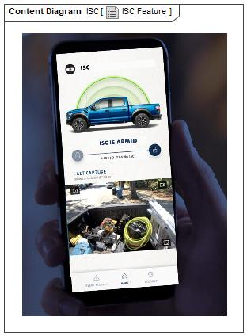

Figure 1: ISC Feature

## Feature Variants

|  |  |  |
| --- | --- | --- |
| **Variant Name** | **Variant Description** | **Remarks** |
| **[1] Pre-Phase 1** | MVP - 1 CSM unit for cab. 1 or 2 internal/external cameras for cab and bed area. SYNC QNX fitted. 360 degree external cameras may optionally be installed. No recording of video to the cloud or USB. |  |
| **[2] P708 MVP Phase 1** | 1 CSM unit for cab. 1 x internal camera for cab area. SYNC QNX fitted. External cameras TBE. Storage of video to the cloud. |  |
| **[3] V710 MVP Phase 1** | Cargo van version (optionally bus). Bed radar not installed - only for pick-up vehicles. 2 CSM units, one for cab and one for cargo area. 360 degree camera system may optionally be fitted. 1 or 2 internal cameras for cab area and optionally cargo/2nd row seat area. SYNC QNX installed. Records video to cloud and USB. |  |
| **[4] V710 ICA MVP Phase 2** | Cargo van version (optionally bus). Bed radar not installed - only for pick-up vehicles. 2 CSM units, one for cab and one for cargo area. 360 degree camera system may be fitted. 1 or 2 internal cameras for cab area and optionally cargo/2nd row seat area. Phoenix installed. Records video to cloud and USB.  Adds to MVP:Possibly Audio Deterrent, Audio Detection in cab & Auto Camera Selection. |  |
| **[5] CDX747 MVP Phase 2** | MVP - Passenger car version. 1 CSM unit for cab. 1 or 2 internal cameras depending on size of vehicle. 360 degree camera may optionally be installed. No radar system fitted as this is for pick-up trucks only. Phoenix used, not SYNC QNX, with digital interior cameras. Records video to cloud and USB. | **SCOPE OF THIS DOCUMENT – Variant 5 only** |
| **[6] P702 MCA MVP Phase 2** | MVP - Pick-up truck version. 1 CSM unit in cab area. 360 degree camera system may optionally be fitted. 1 x 2 internal/external cameras in cab/bed area. Phoenix installed, with digital interior cameras. Records video to cloud and USB. |  |
| **[7] PassCar MVP Phase 3** | MVP - Passenger car version. 1 CSM unit for cab. 1 or 2 internal cameras depending on size of vehicle. 360 degree camera may optionally be installed. No radar system fitted as this is for pick-up trucks only. Phoenix used, not SYNC UNX, with digital interior cameras. Records video to cloud and USB. Adds to MVP: Possibly Audio Deterrent, Audio Detection in cab & Auto Camera Selection. |  |
| **[8] Truck MVP Phase 3** | MVP+ - Pick-up truck version. 1 CSM unit in cab area. 360 degree camera system may optionally be fitted. 1 x 2 internal/external cameras in cab/bed area. Phoenix installed, , with digital interior cameras. Records video to cloud and USB. Adds to MVP: Radar in bed area, possibly Audio Deterrent, Audio Detection in cab & Auto Camera Selection. |  |
| **[9] CDX747 China MVP Phase 2** | MVP - Passenger car version. 1 CSM unit for cab. 1 or 2 internal cameras depending on size of vehicle. 360 degree camera may optionally be installed. No radar system fitted as this is for pick-up trucks only. Phoenix used, not SYNC QNX, , with digital interior cameras. Records video to cloud only. |  |

Table 5: Feature Variants

### Regions & Markets

|  |  |  |  |  |  |  |
| --- | --- | --- | --- | --- | --- | --- |
| **Market /**  **Region**  Variant Name | **North America** | **South America** | **Europe** | **Middle East/Africa** | **Asia / Pacific** | **China** |
| **[1] Pre-Phase 1** | Optional | No | No | No | No | No |
| **[2] P708 MVP Phase 1** | Optional | No | No | No | No | No |
| **[3] V710 MVP Phase 1** | No | No | Optional | No | No | No |
| **[4] V710 ICA MVP Phase 2** | No | No | Optional | No | No | No |
| **[5] CDX747 MVP Phase 2** | Optional | No | Optional | No | No | No |
| **[6] P702 MCA MVP Phase 2** | Optional | No | No | No | No | No |
| **[7] PassCar MVP Phase 3** | Optional | No | Optional | No | No | No |
| **[8] Truck MVP Phase 3** | Optional | No | No | No | No | No |
| **[9] CDX747 China MVP Phase 2** | No | No | No | No | No | Optional |

Table 6: Regions & Markets

## Input Requirements/Documents

### Legal Requirements

* : Compliance with FMVSS101
  + The Feature shall comply with FMVSS101.

### Trustmark Requirements

No Trustmark Requirements specified.

### Industry Standards

* : ISO 26262
  + The system should be developed according to Ford's implementation of Functional Safety.

### Attribute Requirements

#### : Remotely Monitor Vehicle

* + When requested by the user the ISC shall allow remote monitoring of the vehicle
  + **Rationale:** The user needs to be able to monitor their vehicle(s) remotely using on-board cameras and potentially other sensors.

## Lessons Learned

**Quality History Items:**

1. Limited to only one smart phone alert

2. Parking in Area with Poor Cellular Coverage

3. Sudden No Power or Lost communication

4. Sudden block or covering of camera lens

5. Cloud Failure no record of theft attack or recording stops prematurely

6. Poor quality image. Dark image, jerky image

7. Poor Detection performance in rain/snow/hail or adverse weather conditions

8. Road salt, grime, dust, foreign objects on Camera

9. Not Able To Connect Live View As It Is Happening

10. Does not power up

11. Does not respond quick enough for Crash Event

12. Difficult to set up Sentinel on my SmartPhone

13. Fleet User with Multiple Vehicles

## Assumptions

No Assumptions specified.

# Feature Context

## Feature Context Diagram

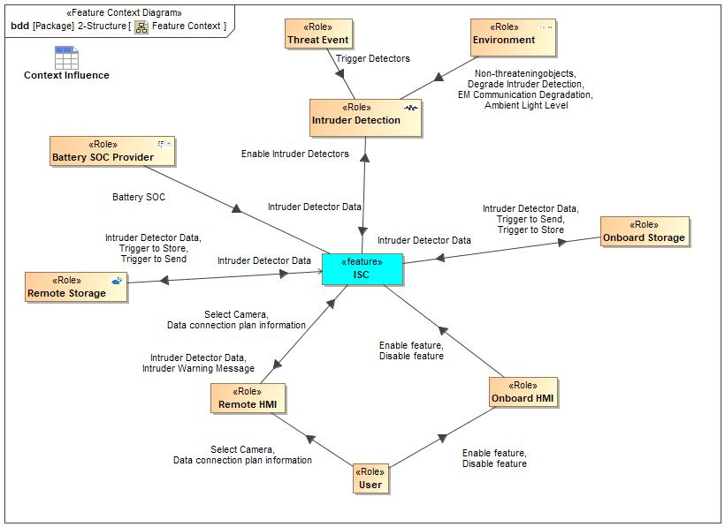

Figure 2: Feature Context

## List of Influences

|  |  |  |
| --- | --- | --- |
| **ID** | **External Entity** | **Influence Description** |
| Ambient Light Level | Environment To Intruder Detection | Wind etc may move vehicle. |
| Battery SOC | Battery SOC Provider To ISC | Electrical power is required by the feature. The battery state of charge (SOC) information is required as Sentinel will need to be disabled if the SOC is below a threshold value. |
| Data connection plan information | Remote HMI To ISC | Information to allow the data connection plan to be established. Information includes paswords and contact information. |
| User To Remote HMI | Information to allow the data connection plan to be established. Information includes paswords and contact information. |
| Degrade Intruder Detection | Environment To ISC | Camera lenses may be obscured preventing clear view. |
| Environment To Intruder Detection | Camera lenses may be obscured preventing clear view. |
| Disable feature | Onboard HMI To ISC | The intruder detectors must be enabled. |
| User To Onboard HMI | The intruder detectors must be enabled. |
| EM Communication Degradation | Environment To Intruder Detection | Signals to the cloud may be attenuated by being in poor signal area on in an enclosed space. |
| Enable feature | Onboard HMI To ISC | The intruder detectors must be enabled. |
| User To Onboard HMI | The intruder detectors must be enabled. |
| Enable Intruder Detectors | ISC To Intruder Detection | The intruder detectors must be enabled. |
| Intruder Detector Data | ISC To Onboard Storage | Data from the various intruder detectors needs to be fed back to the feature. |
| ISC To Remote HMI | Data from the various intruder detectors needs to be fed back to the feature. |
| ISC To Remote Storage | Data from the various intruder detectors needs to be fed back to the feature. |
| Intruder Detection To ISC | Data from the various intruder detectors needs to be fed back to the feature. |
| Onboard Storage To ISC | Data from the various intruder detectors needs to be fed back to the feature. |
| Remote Storage To ISC | Data from the various intruder detectors needs to be fed back to the feature. |
| Intruder Warning Message | ISC To Remote HMI | Intruder warning messages will be fed to the user. |
| Non-threateningobjects | Environment To ISC | Wind etc may move vehicle. |
| Environment To Intruder Detection | Wind etc may move vehicle. |
| Select Camera | Remote HMI To ISC | The User must select which camera to view. |
| User To Remote HMI | The User must select which camera to view. |
| Trigger | Battery SOC Provider To ISC | Influence Description from Documentation field. |
| Trigger Detectors | Threat Event To ISC | Intruder triggers detectors such as: door ajar, accelerometer in vehicle, Ultrasonic detector, radar detector |
| Threat Event To Intruder Detection | Intruder triggers detectors such as: door ajar, accelerometer in vehicle, Ultrasonic detector, radar detector |
| Trigger to Send | ISC To Onboard Storage | The storage of data and the streaming of that data after storage remotely must be enabled and disabled. |
| ISC To Remote Storage | The storage of data and the streaming of that data after storage remotely must be enabled and disabled. |
| Trigger to Store | ISC To Onboard Storage | The storage remotely must be enabled and disabled. |
| ISC To Remote Storage | The storage remotely must be enabled and disabled. |

Table 7: List of Influences

# Feature Modeling

## Operation Modes and States

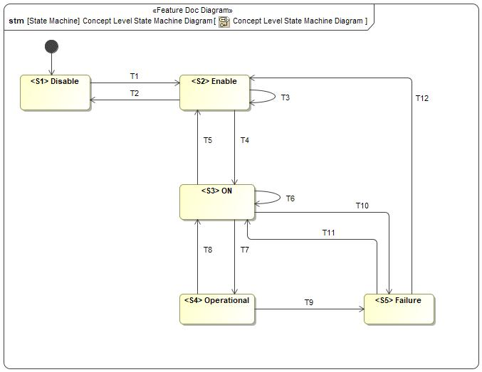

Figure 3: Concept Level State Machine Diagram

|  |  |  |
| --- | --- | --- |
| **State** | **Description** | **Requirements Reference** (optional) |
| <S1> Disable | Feature is disabled by default in the vehicle. Gives freedom to the user to enable the feature. |  |
| <S2> Enable | Feature is enabled by the user in the vehicle Sync Screen |  |
| <S3> ON | User requests the video stream |  |
| <S4> Operational | User views the requested video |  |
| <S5> Failure | Feature is enabled but not operational because of failure |  |

Table 8: Operation Modes and States on Concept Level State Machine Diagram

|  |  |  |  |  |
| --- | --- | --- | --- | --- |
| **Transition ID** | **Source** | **Destination** | **Description** | **Requirements Reference**  (optional) |
| T1 | <S4> Operational | <S3> ON | Documentation: - User terminates the video stream/ Feature less X Time or If/ one of the following conditions is true:  - Low Vehicle Battery  - Communication Faults  - Key ON  - Cameras view Faulted/ Not Available  - Error to encode the video  - Data Plan Not Available  Trigger signal: T8  SignalEvent T8 |  |
| T2 | <S2> Enable | <S1> Disable | Documentation: User disables the feature or Master reset  Trigger signal: T2  SignalEvent T2 |  |
| T3 | <S5> Failure | <S2> Enable | Documentation: : After Tx, Failure detected  T13: User Terminates Feature  Trigger signal: T12  SignalEvent T12 |  |
| T4 | <S2> Enable | <S3> ON | Documentation: User launches and the below conditions are true:  - Vehicle Data plan available  - Vehicle in Key-off  - Vehicle Not in deep sleep mode  Trigger signal: T4  SignalEvent T4 |  |
| T5 | <S3> ON | <S4> Operational | Documentation: User (or Threat Event Alert in certain applications) requests the video stream (and video recording in certain applications) and all of the below conditions are False:  - Low Vehicle Battery  - Key ON  - Cameras view Faulted/ Not Available  - Error to Encode the video  - Data Plan Not Available  Trigger signal: T7  SignalEvent T7 |  |
| T6 | <S3> ON | <S2> Enable | Documentation: User Terminates Feature for more than X time  Trigger signal: T5  SignalEvent T5 |  |
| T7 | <S3> ON | <S3> ON | Documentation: User requests the video stream and all of the below conditions are true:  - Low Vehicle Battery  - Key ON  - Cameras view Faulted/ Not Available  - Error to Encode the video  - Data Plan Not Available  - Cameras view is Not available / Faulted  Trigger signal: T6  SignalEvent T6 |  |
| T8 |  |  |  |  |
| T9 | <S1> Disable | <S2> Enable | Documentation: User Enables the feature  Trigger signal: T1  SignalEvent T1 |  |
| T10 | <S4> Operational | <S5> Failure | Documentation: - Poor cellular connection  - Communication problems within the vehicle components  Trigger signal: T9  SignalEvent T9 |  |
| T11 | <S3> ON | <S5> Failure | Documentation: - Poor cellular connection  - Communication problems within the vehicle components  Trigger signal: T10  SignalEvent T10 |  |
| T12 | <S5> Failure | <S3> ON | Documentation: After Tx, No Failure Detected  Trigger signal: T11  SignalEvent T11 |  |
| T13 | <S2> Enable | <S2> Enable | Documentation: User launches and one of the following conditions is true:  - Vehicle Data plan Not available  - Vehicle is in Key-ON  - Vehicle is in deep sleep mode  Trigger signal: T3  SignalEvent T3 |  |

Table 9: Transitions between Operation Modes and States on Concept Level State Machine Diagram

## Use Cases

### Use Case Diagram

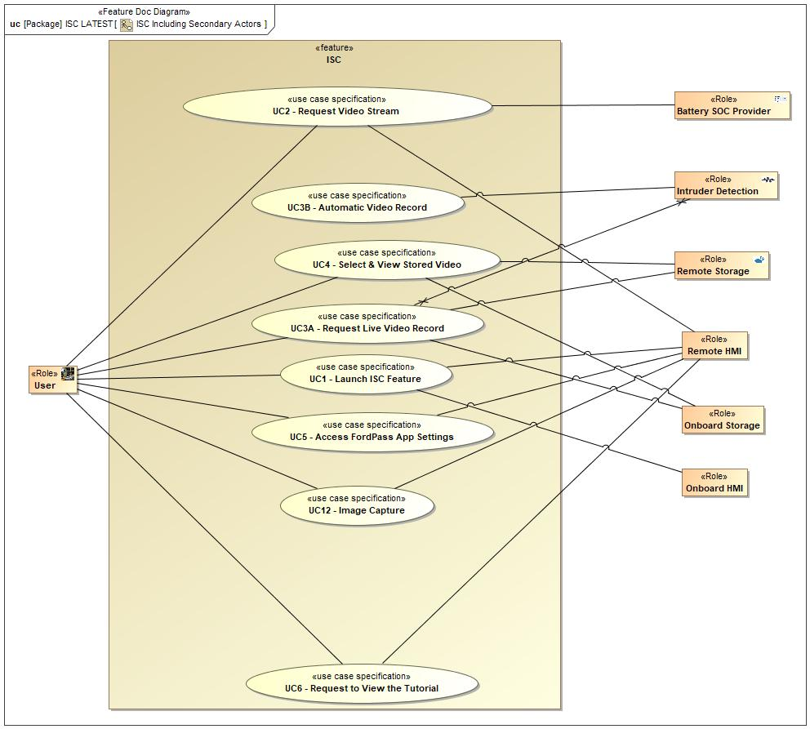

Figure 4: ISC Including Secondary Actors

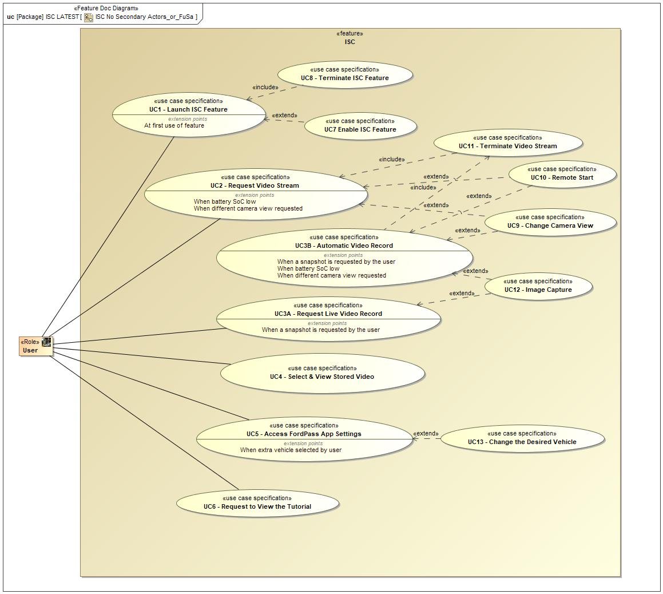

Figure 5: ISC No Secondary Actors_or_FuSa

### Actors

| **Actor** | **Description** |
| --- | --- |
| Battery SOC Provider | The feature requires an electrical power supply. This is important as the vehicle will be powered off during operation of the feature, thus power will be coming from the vehicle battery - battery drain is an important consideration. |
| Intruder Detection | Intruder detection includes all methods used to detect criminal activity on, in or near the vehicle. Typical detectors may be for door ajar, acceleration/vibration/sound, ultrasonic, radar and video. |
| Onboard HMI | The user interface in the vehicle such as SYNC. |
| Onboard Storage | On board storage of intruder detector data for access later by the user. This has limitations versus remote storage, but will not be limited by having good communications to the remote storage site.. |
| Remote HMI | HMI includes on board and remote communication between the feature and the user. |
| Remote Storage | Data from the intruder detectors will be stored remotely. This may allow increased storage capacity and less likelihood of data theft (versus storing in the vehicle). A disadvantage (versus on board storage) is that good communication is required between the vehicle and the remote storage site. |
| User | The user of the system, expected to normally be the driver or owner of the vehicle. Could also be someone involved with operating a commercial fleet of vehicles. |

Table 10: List of Actors

### Use Case Descriptions

UC2 - Request Video Stream

|  |  |  |
| --- | --- | --- |
| **Actors** | Primary | User |
| Secondary | Vehicle |
| **Subject** |  | ISC |
| **Description** |  | Request Video Stream. |
| **Preconditions** | PreC1 | All of the below conditions are false:  - Low Vehicle Battery  - Key ON  - Cameras view Faulted/ Not Available  - Error to Encode the video  - Subscription Not Available  - Cameras view is Not available / Faulted |
| PreC2 | FordPass App Installed. |
| PreC3 | ISC feature is in ON state. |
| **Main Flow Description** |  | Request Video Stream |
| **Main Flow** | M1 | User requests the video stream by selecting the desired Cameras View. |
| **Postconditions** | PostC1 | ISC feature switches to Operational State and displays a video stream. |

UC10 - Remote Start

|  |  |  |
| --- | --- | --- |
| **Actors** | Primary | User |
| Secondary | Vehicle |
| **Subject** |  | ISC |
| **Description** |  | Remote Start |
| **Preconditions** | PreC1 | Approaching low state of charge threshold. |
| PreC2 | Pop-up notifying to use Remote Start to continue viewing the video stream is displayed on FordPass App. |
| **Main Flow Description** |  | Remote Start |
| **Main Flow** | M1 | User goes to Remote Start Feature and activates Remote start to continue viewing the video stream. |
| **Postconditions** | PostC1 | Vehicle triggers remote start and ISC switches to Operational State. |

UC13 - Change the Desired Vehicle

|  |  |  |
| --- | --- | --- |
| **Actors** | Primary | User |
| Secondary | Vehicle |
| **Subject** |  | ISC |
| **Description** |  | Change the Desired Vehicle. |
| **Preconditions** | PreC1 | FordPass App Installed. |
| PreC2 | ISC feature is in Operational State. |
| PreC3 | Ignition OFF |
| **Main Flow Description** |  | Change the Desired Vehicle |
| **Main Flow** | M1 | User terminates the video stream. |
| M2 | User terminates the ISC feature. |
| M3 | User selects another Ford Vehicle. |
| **Postconditions** | PostC1 | The ISC process will be applied for the next vehicle selection. |

UC7 Enable ISC Feature

|  |  |  |
| --- | --- | --- |
| **Actors** | Primary | User |
| Secondary | Vehicle |
| **Subject** |  | ISC |
| **Description** |  | Describes how user enables ISC Feature. |
| **Preconditions** | PreC1 | ISC in Disable state |
| PreC2 | Key-ON |
| **Main Flow Description** |  | Enable ISC Feature |
| **Main Flow** | M1 | User selects the ISC feature enable option on the Vehicle Sync Screen. |
| M2 | User accepts the privacy settings to completely enable the feature. |
| **Postconditions** | PostC1 | ISC feature switches to Enable State. |

UC4 - Select & View Stored Video

|  |  |  |
| --- | --- | --- |
| **Actors** | Primary | User |
| Secondary | Vehicle |
| **Subject** |  | ISC |
| **Description** |  | A selected video recording is played for the user |
| **Preconditions** | PreC1 | ISC feature is in Operational/ ON State |
| **Main Flow Description** |  | Select & View Stored Video |
| **Main Flow** | M1 | User selects video to view |
| M2 | Video player plays video |
| M3 | User requests stop play (or end of video) |
| M4 | Video playing stops |
| **Postconditions** | PostC1 | User has seen video and list of videos available for viewing. |

UC8 - Terminate ISC Feature

|  |  |  |
| --- | --- | --- |
| **Actors** | Primary | User |
| Secondary | Vehicle |
| **Subject** |  | ISC |
| **Description** |  | Terminate the ISC Feature. |
| **Preconditions** | PreC1 | ISC feature is in Operational/ ON State. |
| **Main Flow Description** |  | Terminate ISC Feature |
| **Main Flow** | M1 | User exits the ISC feature. |
| **Postconditions** | PostC1 | The ISC allows to the user to close the FordPass App and switches to ON/ Enable state. |

UC9 - Change Camera View

|  |  |  |
| --- | --- | --- |
| **Actors** | Primary | User |
| Secondary | Vehicle |
| **Subject** |  | ISC |
| **Description** |  | Change Camera View. |
| **Preconditions** | PreC1 | ISC App Installed. |
| PreC2 | ISC feature is in Operational state. |
| PreC3 | Ignition OFF |
| **Main Flow Description** |  | Change Camera View |
| **Main Flow** | M1 | User requests to view another available camera view from the same vehicle. |
| **Postconditions** | PostC1 | ISC feature terminates the current video stream and displays the second stream. |

UC5 - Access FordPass App Settings

|  |  |  |
| --- | --- | --- |
| **Actors** | Primary | User |
| Secondary | Vehicle |
| **Subject** |  | ISC |
| **Description** |  | Access FordPass App Settings. |
| **Preconditions** | PreC1 | FordPass App Installed. |
| PreC2 | ISC is in ON state. |
| **Main Flow Description** |  | Access FordPass App Settings |
| **Main Flow** | M1 | User accesses to FordPass App settings. |
| **Postconditions** | PostC1 | ISC stays in ON state and FordPass App settings are displayed. |

UC11 - Terminate Video Stream

|  |  |  |
| --- | --- | --- |
| **Actors** | Primary | User |
| Secondary | Vehicle |
| **Subject** |  | ISC |
| **Description** |  | Terminate Video Stream. |
| **Preconditions** | PreC1 | ISC feature is in Operational State. |
| **Main Flow Description** |  | Terminate Video Stream |
| **Main Flow** | M1 | User terminates video stream. |
| **Postconditions** | PostC1 | ISC feature switch to ON state. |
| PostC2 | Video stream is terminated. |

UC12 - Image Capture

|  |  |  |
| --- | --- | --- |
| **Actors** | Primary | User |
| Secondary | Vehicle |
| **Subject** |  | ISC |
| **Description** |  | IF the user wants to capture images while streaming video. |
| **Preconditions** | PreC1 | ISC is in Operational state. |
| **Main Flow Description** |  | Image Capture |
| **Main Flow** | M1 | The user viewing the video stream. |
| M2 | User captures the image. |
| **Postconditions** | PostC1 | The ISC feature saves the Captured images in the mobile device. |

UC3A - Request Live Video Record

|  |  |  |
| --- | --- | --- |
| **Actors** | Primary | User |
| Secondary | Vehicle |
| **Subject** |  | ISC |
| **Description** |  | Request to Record Live Video Stream |
| **Preconditions** | PreC1 | ISC feature is in Operational/ ON State |
| **Main Flow Description** |  | Store Video Data |
| **Main Flow** | M1 | A live video stream is in progress |
| M2 | The user requests to record the live video stream |
| M3 | Video is stored on storage media |
| M4 | Video streaming terminates |
| M5 | Video storing terminates |
| **Postconditions** | PostC1 | Video is stored and available for viewing in the future |

UC1 - Launch ISC Feature

|  |  |  |
| --- | --- | --- |
| **Actors** | Primary | User |
| Secondary | Vehicle |
| **Subject** |  | ISC |
| **Description** |  | Describes how user launches ISC Feature |
| **Preconditions** | PreC1 | Available Subscription |
| PreC2 | FordPass App Installed. |
| PreC3 | ISC feature is in Enable state. |
| PreC4 | Key-OFF/ Remote Start |
| PreC5 | No Deep Sleep Mode |
| **Main Flow Description** |  | User launches ISC feature from FordPass App |
| **Main Flow** | M1 | User launches ISC feature from FordPass App. |
| **Postconditions** | PostC1 | ISC feature switches to ON state. |

UC3B - Automatic Video Record

|  |  |  |
| --- | --- | --- |
| **Actors** | Primary | User |
| Secondary | Vehicle |
| **Subject** |  | ISC |
| **Description** |  | Automatic Video Stream & Record |
| **Preconditions** | PreC1 | ISC feature is in Operational/ ON State |
| **Main Flow Description** |  | Automatic video streaming and recording following a threat event. This includes a threat event alert notification. |
| **Main Flow** | M1 | A threat event is detected |
| M2 | A live video stream is in progress |
| M3 | Video is stored on storage media |
| M4 | Video streaming terminates |
| M5 | Video storing terminates |
| **Postconditions** | PostC1 | Video is stored and available for viewing in the future |

UC6 - Request to View the Tutorial

|  |  |  |
| --- | --- | --- |
| **Actors** | Primary | User |
| Secondary | Vehicle |
| **Subject** |  | ISC |
| **Description** |  | Request to View the Tutorial. |
| **Preconditions** | PreC1 | FordPass Application Installed. |
| PreC2 | ISC feature is in ON state. |
| **Main Flow Description** |  | Request to View the Tutorial |
| **Main Flow** | M1 | User requests to view a tutorial of how the feature is operated. |
| **Postconditions** | PostC1 | ISC stays in ON state and displays the tutorial |

## Driving and Operation Scenarios

###SC_F_ISC_00001### Launch ISC Feature when the Vehicle is in Deep Sleep Mode

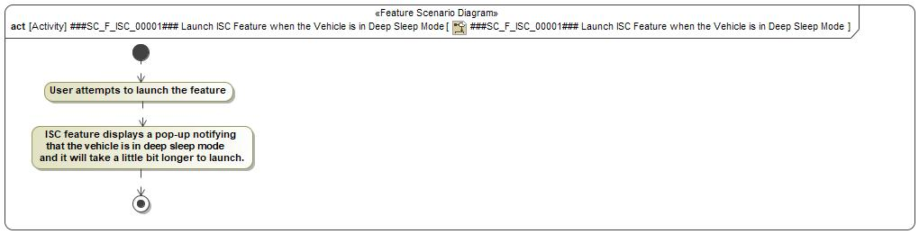

###SC_F_ISC_00002### Launch ISC Feature when the Vehicle is in Key ON

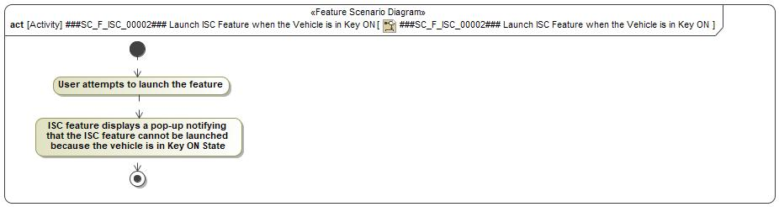

###SC_F_ISC_00003### Launch ISC Feature when the Vehicle Subscription not Available

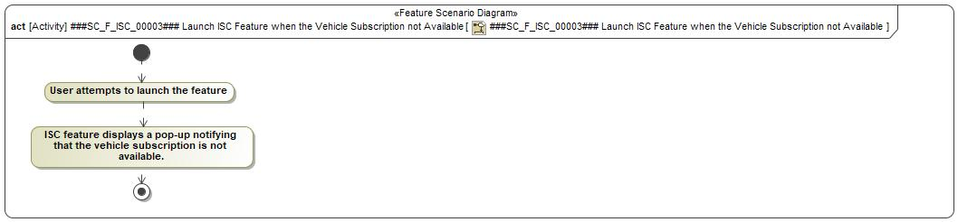

###SC_F_ISC_00004### Launch ISC Feature when the Vehicle in Low Battery State of Charge

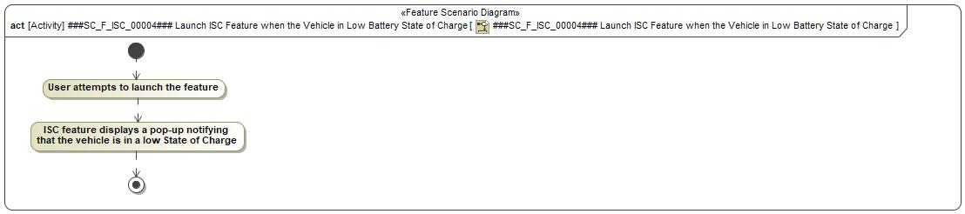

###SC_F_ISC_00005### Launch ISC Feature when it is in Disable State

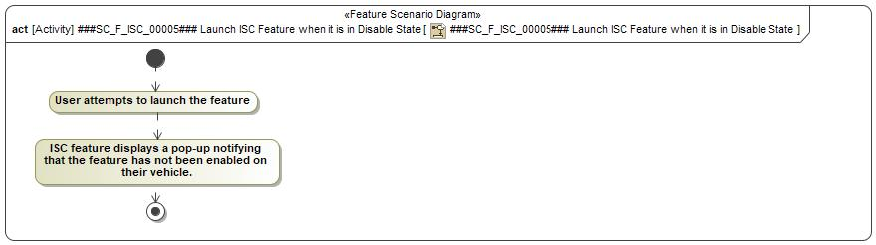

###SC_F_ISC_00006### Request Video Stream When the Vehicle is in Low Battery State of Charge

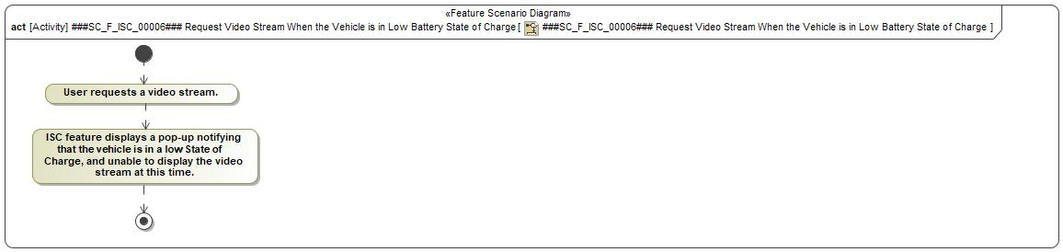

###SC_F_ISC_00007### Request Video Stream When Modules are Occupied

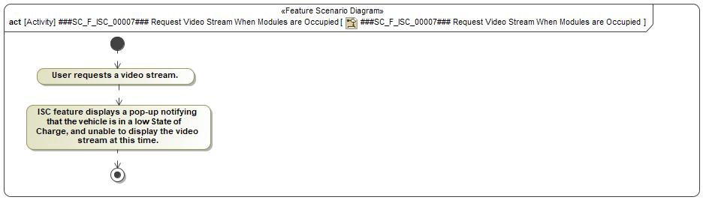

###SC_F_ISC_00008### Request Video Stream When Communication Lost

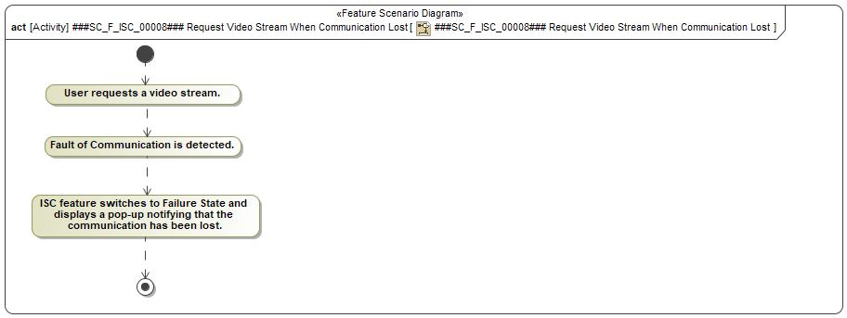

###SC_F_ISC_00009### Request Video Stream When Camera View is Not Available/ Faulted

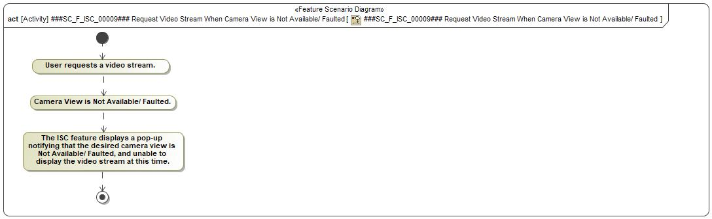

###SC_F_ISC_00010### Request Video Stream When Key ON detected

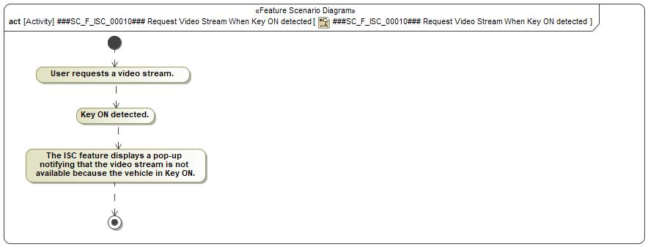

###SC_F_ISC_00011### Request Video Stream When the Vehicle Subscription are Not Available

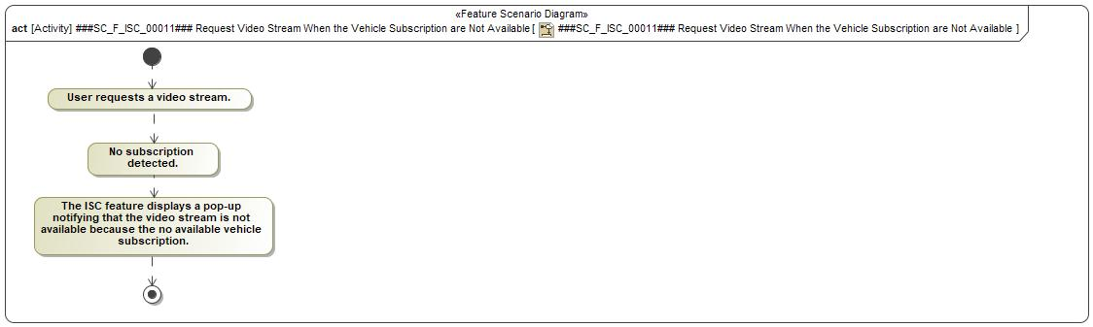

###SC_F_ISC_00012### Request Video stream and Video Error Detected

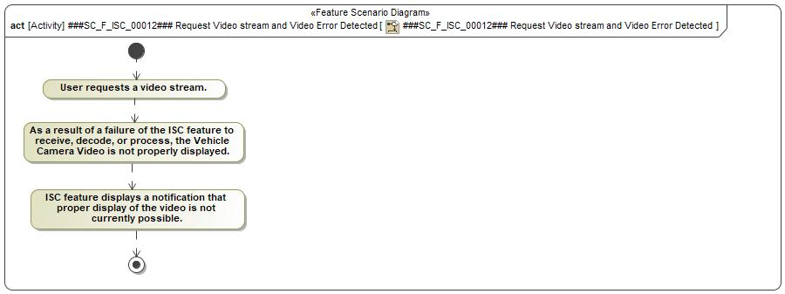

###SC_F_ISC_00013### Request Video Stream by Two Different Users

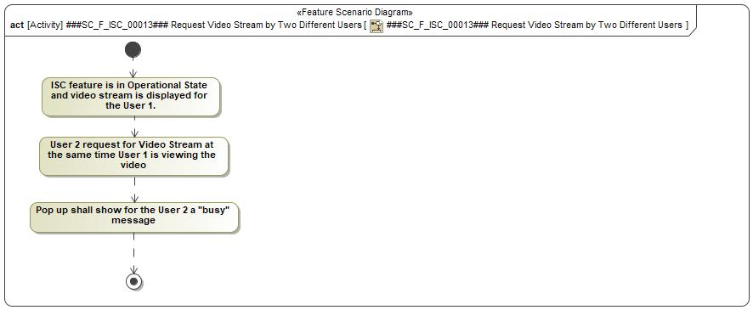

###SC_F_ISC_00014### Be Notified of Threat Event

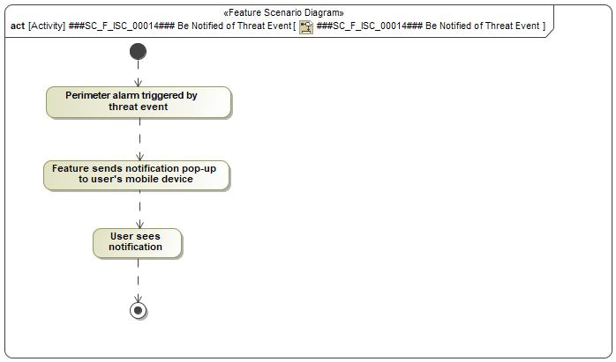

###SC_F_ISC_00015### Automatically Select Most Appropriate Camera View

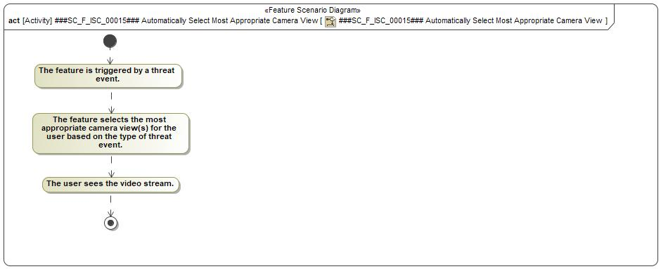

###SC_F_ISC_00016### Store Data to Cloud

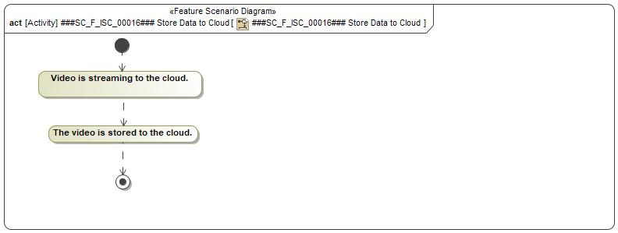

###SC_F_ISC_00017### Store Data to USB

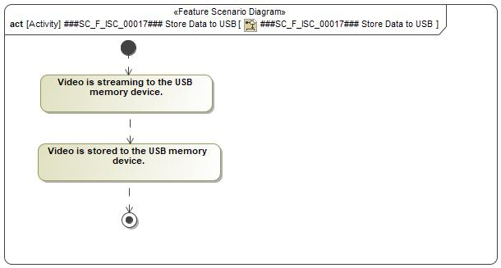

###SC_F_ISC_00018### Store Snapshot to Mobile Device Memory

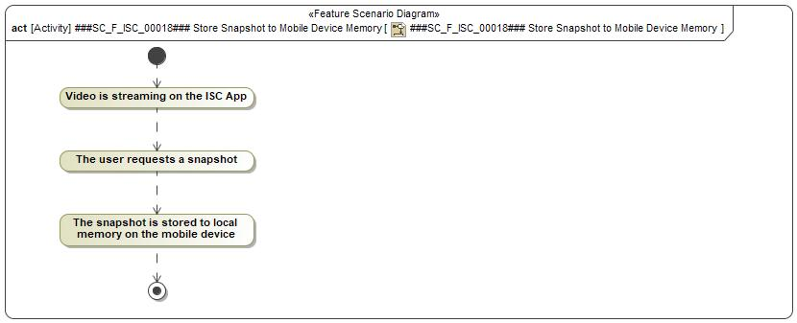

###SC_F_ISC_00020### Request Stored Video Stream on ISC App

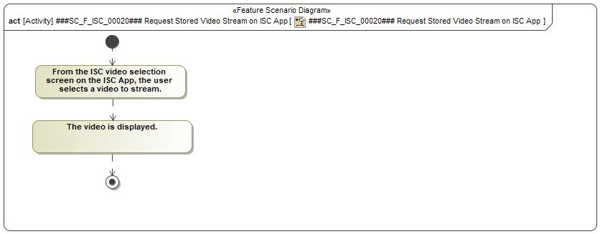

###SC_F_ISC_00021### Request Stored Video Stream on APIM Display

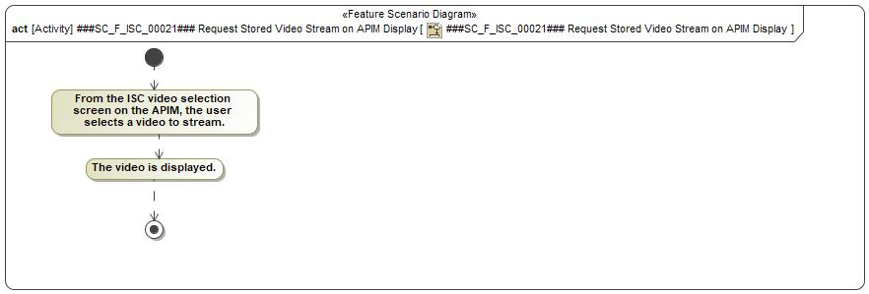

###SC_F_ISC_00022### Request Stored Snapshot Photo on Mobile Device

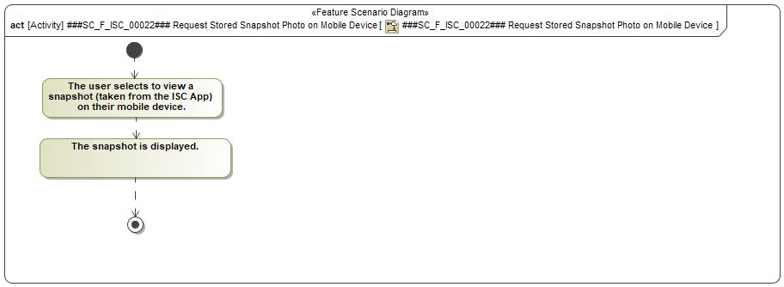

###SC_F_ISC_00023### Video Quality Settings

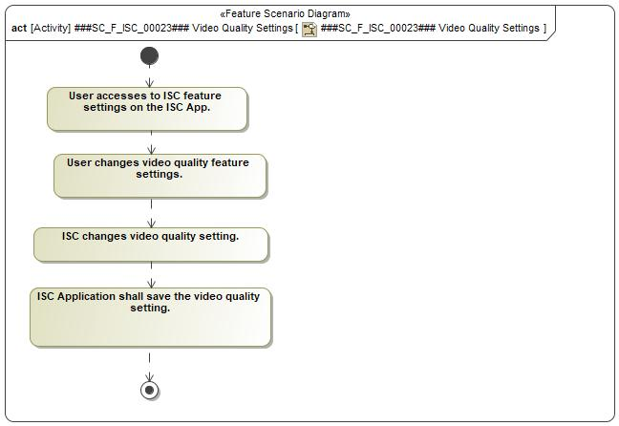

###SC_F_ISC_00024### Default View Settings

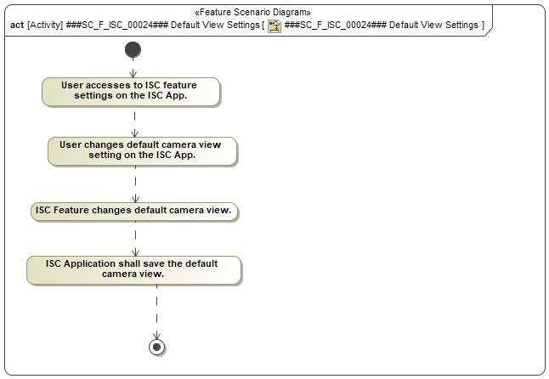

###SC_F_ISC_00027### Set Configuration - Disable Threat Event Notifications

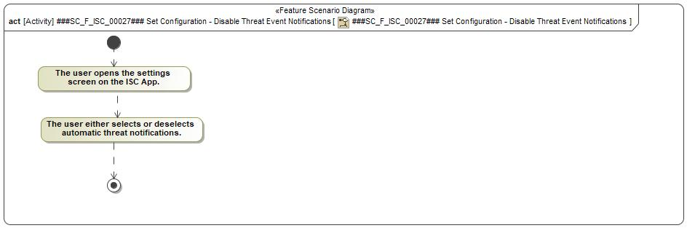

###SC_F_ISC_00028### View Tutorial

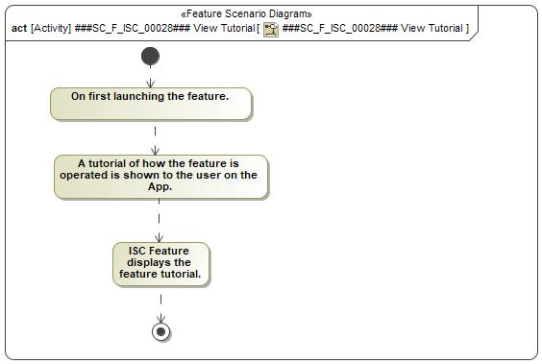

###SC_F_ISC_00029### Skip Tutorial

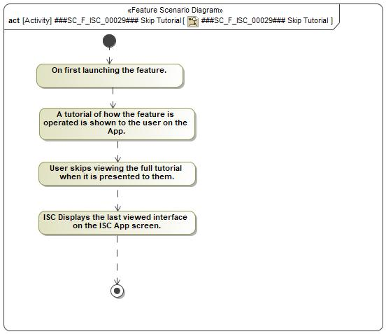

###SC_F_ISC_00030### Terminate Video stream When the Vehicle is in Low Battery State of Charge

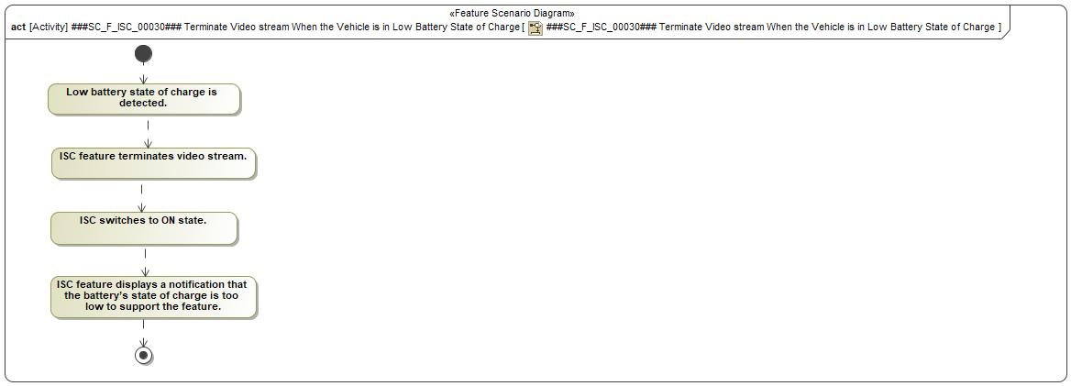

###SC_F_ISC_00031### Terminate Video Stream When Communication with Vehicle Lost

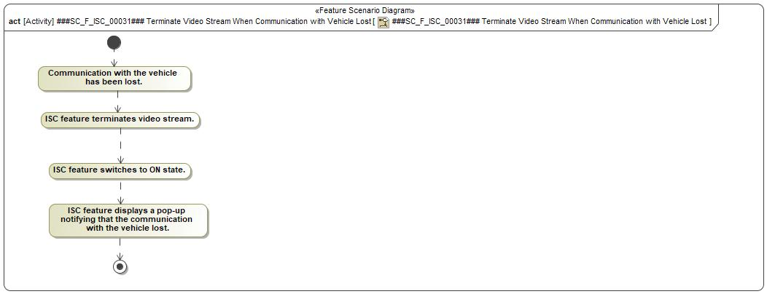

###SC_F_ISC_00032### Terminate Video Stream when Video Error Detected

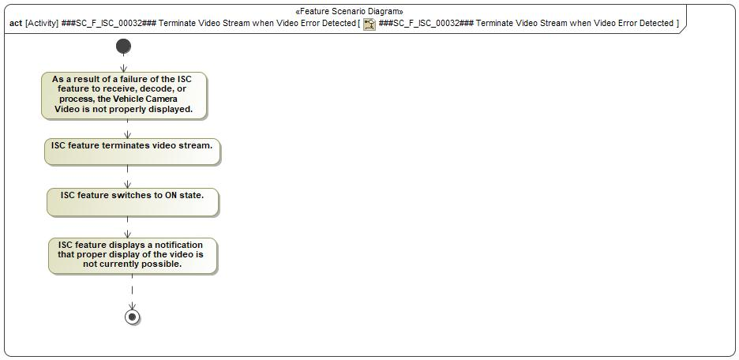

###SC_F_ISC_00033### Terminate Video Stream when Cameras View Not Available/ Faulted

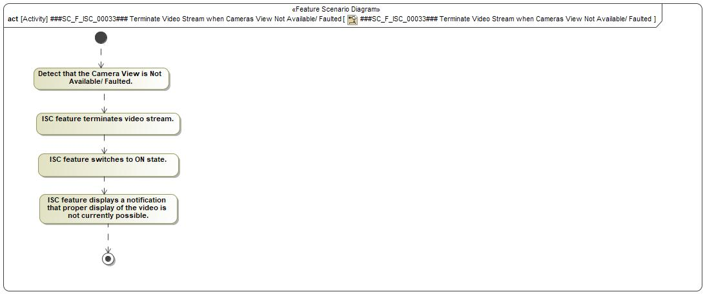

###SC_F_ISC_00034### Terminate Video Stream When the Vehicle Subscription are not Available

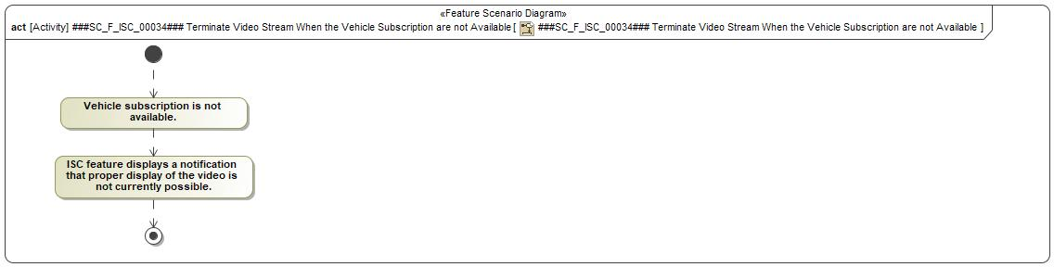

###SC_F_ISC_00035### Terminate Video Stream When Key ON is Detected

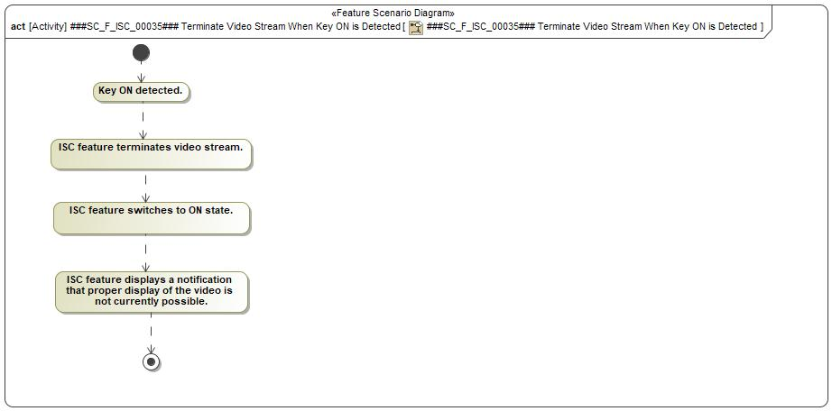

###SC_F_ISC_00036### Terminate Video Stream on ISC App at User Request

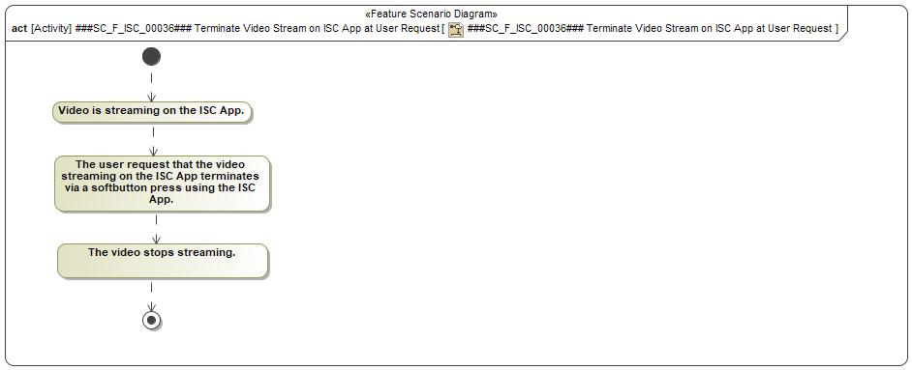

###SC_F_ISC_00037### Terminate Video Stream on ISC App at End of Video Clip

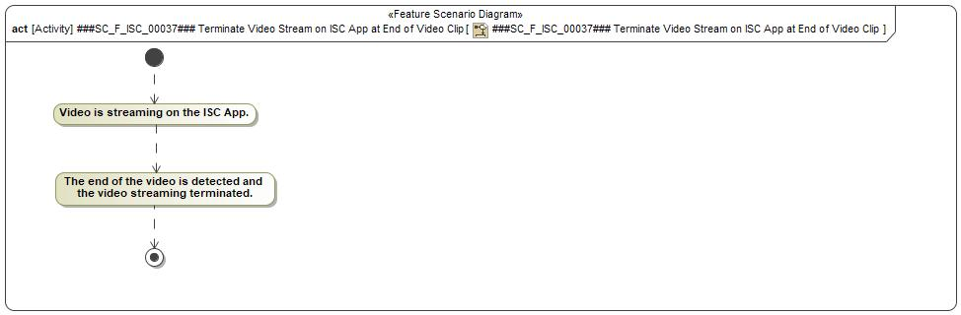

###SC_F_ISC_00038### Terminate Video Replay on APIM Display at User Request

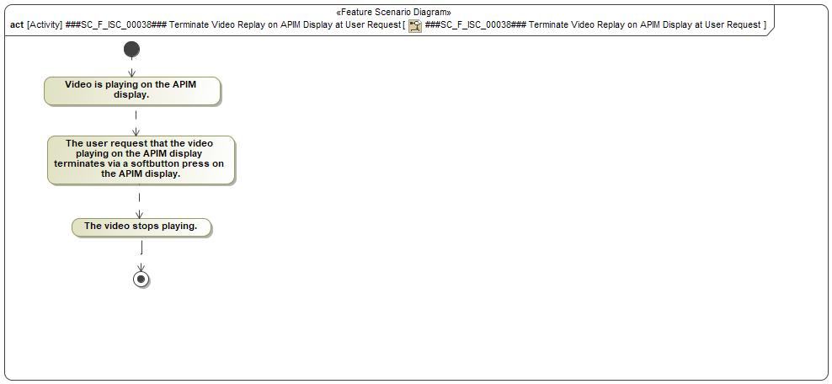

###SC_F_ISC_00039### Terminate Video Stream on APIM Display at End of Video Clip

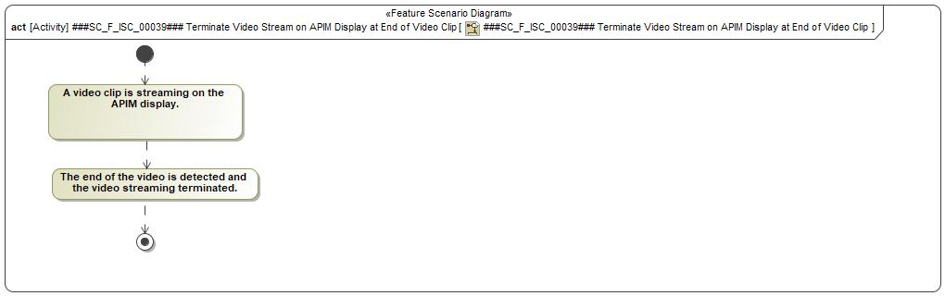

ISC Scenarios - Overview

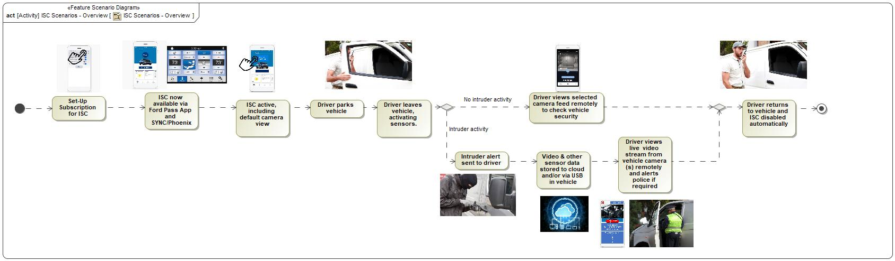

## Decision Tables

*Not supported by MagicDraw report generation.*

# Feature Requirements

## Functional Requirements

ISC_FR_1 Launch Feature Using Ford Pass App

The ISC feature shall be launched by the user in the Ford Pass App. the ISC Feature shall be launched by the user in the Ford Pass App.

|  |  |  |  |  |  |  |  |
| --- | --- | --- | --- | --- | --- | --- | --- |
| Requirement ID: ISC_FR_1 | | | | | | | |
| **Rationale** | The Ford Pass App is launced via a mobile device | | | | | | |
| **Acceptance Criteria** | See Test Plan | | | | | | |
| **Notes** |  | | | | | | |
| **Source** |  | | | | | **Owner** | I Gupta (igupta1), M Wohlfahter (mwohlfah), C Minous (cminous), S Dogiparthi (sdogipar) |
| **Source Req.** | * 1565622794.jpg Remotely Monitor Vehicle | | | | | **V&V Method** | See Test Plan |
| **Type** |  | | | **Priority** | 1 - High | **Status** | In-Progress |
| [Req. Template](http://wiki.ford.com/display/RequirementsEngineering/Requirements+Attributes) Version | | 6.0 | End of Requirement | | | | |

ISC_FR_2 Launch Conditions for ISC Feature

When the user tried to launch ISC feature and one of the following conditions is true:

- ISC in Disable State

- Vehicle in Deep Sleep mode

- Vehicle in Key ON

- Vehicle subscription not available

- Low Vehicle Battery

the ISC Feature shall display a pop-up notifying that the feature cannot be launched for one of the stated reasons

|  |  |  |  |  |  |  |  |
| --- | --- | --- | --- | --- | --- | --- | --- |
| Requirement ID: ISC_FR_2 | | | | | | | |
| **Rationale** | The user needs to know why the Ford Pass App will not launch | | | | | | |
| **Acceptance Criteria** | See Test Plan | | | | | | |
| **Notes** |  | | | | | | |
| **Source** |  | | | | | **Owner** | I Gupta (igupta1), M Wohlfahter (mwohlfah), C Minous (cminous), S Dogiparthi (sdogipar) |
| **Source Req.** | * 1565622794.jpg Remotely Monitor Vehicle | | | | | **V&V Method** | See Test Plan |
| **Type** |  | | | **Priority** | 1 - High | **Status** | In-Progress |
| [Req. Template](http://wiki.ford.com/display/RequirementsEngineering/Requirements+Attributes) Version | | 6.0 | End of Requirement | | | | |

ISC_FR_3 ISC Feature - Enable/Disable

At user request using a soft button (on the APIM display) the ISC Feature shall allow enabling/disabling of the ISC Feature.

|  |  |  |  |  |  |  |  |
| --- | --- | --- | --- | --- | --- | --- | --- |
| Requirement ID: ISC_FR_3 | | | | | | | |
| **Rationale** | This is how the ISC Feature is enabled/disabled | | | | | | |
| **Acceptance Criteria** | See Test Plan | | | | | | |
| **Notes** |  | | | | | | |
| **Source** |  | | | | | **Owner** | I Gupta (igupta1), M Wohlfahter (mwohlfah), C Minous (cminous), S Dogiparthi (sdogipar) |
| **Source Req.** | * 1565622794.jpg Remotely Monitor Vehicle | | | | | **V&V Method** | See Test Plan |
| **Type** |  | | | **Priority** | 1 - High | **Status** | In-Progress |
| [Req. Template](http://wiki.ford.com/display/RequirementsEngineering/Requirements+Attributes) Version | | 6.0 | End of Requirement | | | | |

ISC_FR_4 Threat Event Notification

When a threat event is detected the ISC Feature shall send a threat notification to the user

|  |  |  |  |  |  |  |  |
| --- | --- | --- | --- | --- | --- | --- | --- |
| Requirement ID: ISC_FR_4 | | | | | | | |
| **Rationale** | To inform the user of a threat event | | | | | | |
| **Acceptance Criteria** | See Test Plan | | | | | | |
| **Notes** |  | | | | | | |
| **Source** |  | | | | | **Owner** | I Gupta (igupta1), M Wohlfahter (mwohlfah), C Minous (cminous), S Dogiparthi (sdogipar) |
| **Source Req.** | * 1565622794.jpg Remotely Monitor Vehicle | | | | | **V&V Method** | See Test Plan |
| **Type** |  | | | **Priority** | 1 - High | **Status** | In-Progress |
| [Req. Template](http://wiki.ford.com/display/RequirementsEngineering/Requirements+Attributes) Version | | 6.0 | End of Requirement | | | | |

ISC_FR_6 Display Pop-up/Notification

When one of the following conditions are met:

- Camera view unavailable

- Communication faults

- Vehicle battery is in a low State of Charge

- Vehicle modules are occupied

- Mobile unable to decode the video stream

- Key ON

- No vehicle subscription the ISC Feature shall display a pop-up (ie notfication)

|  |  |  |  |  |  |  |  |
| --- | --- | --- | --- | --- | --- | --- | --- |
| Requirement ID: ISC_FR_6 | | | | | | | |
| **Rationale** | To inform the user of a threat event | | | | | | |
| **Acceptance Criteria** | See Test Plan | | | | | | |
| **Notes** |  | | | | | | |
| **Source** |  | | | | | **Owner** | I Gupta (igupta1), M Wohlfahter (mwohlfah), C Minous (cminous), S Dogiparthi (sdogipar) |
| **Source Req.** | * 1565622794.jpg Remotely Monitor Vehicle | | | | | **V&V Method** | See Test Plan |
| **Type** |  | | | **Priority** | 1 - High | **Status** | In-Progress |
| [Req. Template](http://wiki.ford.com/display/RequirementsEngineering/Requirements+Attributes) Version | | 6.0 | End of Requirement | | | | |

ISC_FR_7 Request Video Stream

When requested by the user the ISC Feature shall allow to the user to request a video stream from one of the available vehicle camera views.

|  |  |  |  |  |  |  |  |
| --- | --- | --- | --- | --- | --- | --- | --- |
| Requirement ID: ISC_FR_7 | | | | | | | |
| **Rationale** | To allow the user ot monitor the vehicle remotely | | | | | | |
| **Acceptance Criteria** | See Test Plan | | | | | | |
| **Notes** |  | | | | | | |
| **Source** |  | | | | | **Owner** | I Gupta (igupta1), M Wohlfahter (mwohlfah), C Minous (cminous), S Dogiparthi (sdogipar) |
| **Source Req.** | * 1565622794.jpg Remotely Monitor Vehicle | | | | | **V&V Method** | See Test Plan |
| **Type** |  | | | **Priority** | 1 - High | **Status** | In-Progress |
| [Req. Template](http://wiki.ford.com/display/RequirementsEngineering/Requirements+Attributes) Version | | 6.0 | End of Requirement | | | | |

ISC_FR_8 Video Image Quality

When streaming video the ISC Feature shall provide a suitable video image quality and coverage under a range of lighting conditions

|  |  |  |  |  |  |  |  |
| --- | --- | --- | --- | --- | --- | --- | --- |
| Requirement ID: ISC_FR_8 | | | | | | | |
| **Rationale** | At least acceptable video quality is required, even in the dark | | | | | | |
| **Acceptance Criteria** | See Test Plan | | | | | | |
| **Notes** |  | | | | | | |
| **Source** |  | | | | | **Owner** | I Gupta (igupta1), M Wohlfahter (mwohlfah), C Minous (cminous), S Dogiparthi (sdogipar) |
| **Source Req.** | * 1565622794.jpg Remotely Monitor Vehicle | | | | | **V&V Method** | See Test Plan |
| **Type** |  | | | **Priority** | 1 - High | **Status** | In-Progress |
| [Req. Template](http://wiki.ford.com/display/RequirementsEngineering/Requirements+Attributes) Version | | 6.0 | End of Requirement | | | | |

ISC_FR_9 Display Video Stream

When all the following conditions are false:

- Camera view unavailable

- Communication Faults

- Vehicle Battery is in a Low State of Charge

- Vehicle Modules are Occupied

- Mobile unable to decode the stream video

- Key ON

- No vehicle subscription

the ISC Feature shall display the video stream.

|  |  |  |  |  |  |  |  |
| --- | --- | --- | --- | --- | --- | --- | --- |
| Requirement ID: ISC_FR_9 | | | | | | | |
| **Rationale** | Conditions must be met to allow video streaming | | | | | | |
| **Acceptance Criteria** | See Test Plan | | | | | | |
| **Notes** |  | | | | | | |
| **Source** |  | | | | | **Owner** | I Gupta (igupta1), M Wohlfahter (mwohlfah), C Minous (cminous), S Dogiparthi (sdogipar) |
| **Source Req.** | * 1565622794.jpg Remotely Monitor Vehicle | | | | | **V&V Method** | See Test Plan |
| **Type** |  | | | **Priority** | 2 - Medium | **Status** | In-Progress |
| [Req. Template](http://wiki.ford.com/display/RequirementsEngineering/Requirements+Attributes) Version | | 6.0 | End of Requirement | | | | |

ISC_FR_10 Display Available Camera Views

Upon launching the feature the ISC Feature shall display all the available cameras view with their current status.

|  |  |  |  |  |  |  |  |
| --- | --- | --- | --- | --- | --- | --- | --- |
| Requirement ID: ISC_FR_10 | | | | | | | |
| **Rationale** | The user needs to know which camera views are available | | | | | | |
| **Acceptance Criteria** | See Test Plan | | | | | | |
| **Notes** |  | | | | | | |
| **Source** |  | | | | | **Owner** | I Gupta (igupta1), M Wohlfahter (mwohlfah), C Minous (cminous), S Dogiparthi (sdogipar) |
| **Source Req.** | * 1565622794.jpg Remotely Monitor Vehicle | | | | | **V&V Method** | See Test Plan |
| **Type** |  | | | **Priority** | 2 - Medium | **Status** | In-Progress |
| [Req. Template](http://wiki.ford.com/display/RequirementsEngineering/Requirements+Attributes) Version | | 6.0 | End of Requirement | | | | |

ISC_FR_11 Terminate Video Stream

When any of the below reasons is met:

- User terminates video stream

- Vehicle Battery is in a Low State of Charge

- Communication lost

- Mobile unable to decode the stream video

- Key ON

- Camera view unavailable

- Vehicle Modules are Occupied

- No vehicle subscription

the ISC Feature shall terminate the video stream.

|  |  |  |  |  |  |  |  |
| --- | --- | --- | --- | --- | --- | --- | --- |
| Requirement ID: ISC_FR_11 | | | | | | | |
| **Rationale** | These condtions must be met to terminate the video streaming | | | | | | |
| **Acceptance Criteria** | See Test Plan | | | | | | |
| **Notes** |  | | | | | | |
| **Source** |  | | | | | **Owner** | I Gupta (igupta1), M Wohlfahter (mwohlfah), C Minous (cminous), S Dogiparthi (sdogipar) |
| **Source Req.** | * 1565622794.jpg Remotely Monitor Vehicle | | | | | **V&V Method** | See Test Plan |
| **Type** |  | | | **Priority** | 2 - Medium | **Status** | In-Progress |
| [Req. Template](http://wiki.ford.com/display/RequirementsEngineering/Requirements+Attributes) Version | | 6.0 | End of Requirement | | | | |

ISC_FR_12 Terminate Ford Pass App

When requested by the user the ISC Feature shall allow to the user to exit the Ford Pass App.

|  |  |  |  |  |  |  |  |
| --- | --- | --- | --- | --- | --- | --- | --- |
| Requirement ID: ISC_FR_12 | | | | | | | |
| **Rationale** | The user may wish to terminate the video streaming | | | | | | |
| **Acceptance Criteria** | See Test Plan | | | | | | |
| **Notes** |  | | | | | | |
| **Source** |  | | | | | **Owner** | I Gupta (igupta1), M Wohlfahter (mwohlfah), C Minous (cminous), S Dogiparthi (sdogipar) |
| **Source Req.** | * 1565622794.jpg Remotely Monitor Vehicle | | | | | **V&V Method** | See Test Plan |
| **Type** |  | | | **Priority** | 2 - Medium | **Status** | In-Progress |
| [Req. Template](http://wiki.ford.com/display/RequirementsEngineering/Requirements+Attributes) Version | | 6.0 | End of Requirement | | | | |

ISC_FR_15 Settings - ISC Feature

When the Ford Pass App is enabled the ISC Feature shall allow the user to access ISC settings in the Ford Pass App.

|  |  |  |  |  |  |  |  |
| --- | --- | --- | --- | --- | --- | --- | --- |
| Requirement ID: ISC_FR_15 | | | | | | | |
| **Rationale** | To allow the user to adjust preferences | | | | | | |
| **Acceptance Criteria** | See Test Plan | | | | | | |
| **Notes** |  | | | | | | |
| **Source** |  | | | | | **Owner** | I Gupta (igupta1), M Wohlfahter (mwohlfah), C Minous (cminous), S Dogiparthi (sdogipar) |
| **Source Req.** | * 1565622794.jpg Remotely Monitor Vehicle | | | | | **V&V Method** | See Test Plan |
| **Type** |  | | | **Priority** | 2 - Medium | **Status** | In-Progress |
| [Req. Template](http://wiki.ford.com/display/RequirementsEngineering/Requirements+Attributes) Version | | 6.0 | End of Requirement | | | | |

ISC_FR_16 Settings - Video Quality

When the Ford Pass App is enabled the ISC Feature shall allow the user to adjust the video stream quality if needed.

|  |  |  |  |  |  |  |  |
| --- | --- | --- | --- | --- | --- | --- | --- |
| Requirement ID: ISC_FR_16 | | | | | | | |
| **Rationale** | To adjust the video quality as this may affect the length of video clips recorded and/or the communication speed to the ISC Cloud | | | | | | |
| **Acceptance Criteria** | See Test Plan | | | | | | |
| **Notes** |  | | | | | | |
| **Source** |  | | | | | **Owner** | I Gupta (igupta1), M Wohlfahter (mwohlfah), C Minous (cminous), S Dogiparthi (sdogipar) |
| **Source Req.** | * 1565622794.jpg Remotely Monitor Vehicle | | | | | **V&V Method** | See Test Plan |
| **Type** |  | | | **Priority** | 3 - Low | **Status** | In-Progress |
| [Req. Template](http://wiki.ford.com/display/RequirementsEngineering/Requirements+Attributes) Version | | 6.0 | End of Requirement | | | | |

ISC_FR_17 Settings - Default View

By using a soft button on Ford Pass App the ISC Feature shall allow the user to select any of the available camera view as a default view.

|  |  |  |  |  |  |  |  |
| --- | --- | --- | --- | --- | --- | --- | --- |
| Requirement ID: ISC_FR_17 | | | | | | | |
| **Rationale** | To allow the selection of the most appropriate camera view as the default | | | | | | |
| **Acceptance Criteria** | See Test Plan | | | | | | |
| **Notes** |  | | | | | | |
| **Source** |  | | | | | **Owner** | I Gupta (igupta1), M Wohlfahter (mwohlfah), C Minous (cminous), S Dogiparthi (sdogipar) |
| **Source Req.** | * 1565622794.jpg Remotely Monitor Vehicle | | | | | **V&V Method** | See Test Plan |
| **Type** |  | | | **Priority** | 2 - Medium | **Status** | In-Progress |
| [Req. Template](http://wiki.ford.com/display/RequirementsEngineering/Requirements+Attributes) Version | | 6.0 | End of Requirement | | | | |

ISC_FR_18 Settings - Change Camera View

By using a soft button on the Ford Pass App the ISC Feature shall allow the user to change the camera view after terminating the current video stream.

|  |  |  |  |  |  |  |  |
| --- | --- | --- | --- | --- | --- | --- | --- |
| Requirement ID: ISC_FR_18 | | | | | | | |
| **Rationale** | To allow the selection of the most appropriate camera view for a particular event | | | | | | |
| **Acceptance Criteria** | See Test Plan | | | | | | |
| **Notes** |  | | | | | | |
| **Source** |  | | | | | **Owner** | I Gupta (igupta1), M Wohlfahter (mwohlfah), C Minous (cminous), S Dogiparthi (sdogipar) |
| **Source Req.** | * 1565622794.jpg Remotely Monitor Vehicle | | | | | **V&V Method** | See Test Plan |
| **Type** |  | | | **Priority** | 1 - High | **Status** | In-Progress |
| [Req. Template](http://wiki.ford.com/display/RequirementsEngineering/Requirements+Attributes) Version | | 6.0 | End of Requirement | | | | |

ISC_FR_19 Settings - Change Vehicle

By using a soft button on the Ford Pass App the ISC Feature shall allow the user to switch to the desired vehicle after terminating the ISC feature for the current vehicle.

|  |  |  |  |  |  |  |  |
| --- | --- | --- | --- | --- | --- | --- | --- |
| Requirement ID: ISC_FR_19 | | | | | | | |
| **Rationale** | To allow the user to switch to the video streaming from another vehicle | | | | | | |
| **Acceptance Criteria** | See Test Plan | | | | | | |
| **Notes** |  | | | | | | |
| **Source** |  | | | | | **Owner** | I Gupta (igupta1), M Wohlfahter (mwohlfah), C Minous (cminous), S Dogiparthi (sdogipar) |
| **Source Req.** | * 1565622794.jpg Remotely Monitor Vehicle | | | | | **V&V Method** | See Test Plan |
| **Type** |  | | | **Priority** | 2 - Medium | **Status** | In-Progress |
| [Req. Template](http://wiki.ford.com/display/RequirementsEngineering/Requirements+Attributes) Version | | 6.0 | End of Requirement | | | | |

ISC_FR_21 Request Remote Start at Low SoC

When approaching low state of charge threshold the ISC Feature shall send a pop-up to the user to use the remote start feature to continue viewing the video stream. (TBE if this is appropriate for an event triggered by the CSM and/or radar)

|  |  |  |  |  |  |  |  |
| --- | --- | --- | --- | --- | --- | --- | --- |
| Requirement ID: ISC_FR_21 | | | | | | | |
| **Rationale** | To allow the vehicle power supply to power the ISC cameras when the battery SoC falls below the required threshold | | | | | | |
| **Acceptance Criteria** | See Test Plan | | | | | | |
| **Notes** |  | | | | | | |
| **Source** |  | | | | | **Owner** | I Gupta (igupta1), M Wohlfahter (mwohlfah), C Minous (cminous), S Dogiparthi (sdogipar) |
| **Source Req.** | * 1565622794.jpg Remotely Monitor Vehicle | | | | | **V&V Method** | See Test Plan |
| **Type** |  | | | **Priority** | 3 - Low | **Status** | In-Progress |
| [Req. Template](http://wiki.ford.com/display/RequirementsEngineering/Requirements+Attributes) Version | | 6.0 | End of Requirement | | | | |

ISC_FR_22 Capture Snapshot Image

When requested by the user the ISC Feature shall allow to the user to capture a snapshot image from the video stream and save to the Mobile Device.

|  |  |  |  |  |  |  |  |
| --- | --- | --- | --- | --- | --- | --- | --- |
| Requirement ID: ISC_FR_22 | | | | | | | |
| **Rationale** | To allow the capture of a still image (snapshot) | | | | | | |
| **Acceptance Criteria** | See Test Plan | | | | | | |
| **Notes** |  | | | | | | |
| **Source** |  | | | | | **Owner** | I Gupta (igupta1), M Wohlfahter (mwohlfah), C Minous (cminous), S Dogiparthi (sdogipar) |
| **Source Req.** | * 1565622794.jpg Remotely Monitor Vehicle | | | | | **V&V Method** | See Test Plan |
| **Type** |  | | | **Priority** | 3 - Low | **Status** | In-Progress |
| [Req. Template](http://wiki.ford.com/display/RequirementsEngineering/Requirements+Attributes) Version | | 6.0 | End of Requirement | | | | |

ISC_FR_23 Two Users Request Video Stream

When user 2 requests the video stream at the same time that user 1 is viewing the video stream the ISC Feature shall display a pop-up for the User 1 notifying that User 2 requests to view the Video stream.

If User 1 accepts the request, the video stream will terminate and User 2 can also request a video stream.

Else, User 1 continues viewing the video stream and User 2 receives a pop-up notifying that User 1 is viewing.

|  |  |  |  |  |  |  |  |
| --- | --- | --- | --- | --- | --- | --- | --- |
| Requirement ID: ISC_FR_23 | | | | | | | |
| **Rationale** | Conflict between two or more users of the Ford Pass App must be avoided | | | | | | |
| **Acceptance Criteria** | See Test Plan | | | | | | |
| **Notes** |  | | | | | | |
| **Source** |  | | | | | **Owner** | I Gupta (igupta1), M Wohlfahter (mwohlfah), C Minous (cminous), S Dogiparthi (sdogipar) |
| **Source Req.** | * 1565622794.jpg Remotely Monitor Vehicle | | | | | **V&V Method** | See Test Plan |
| **Type** |  | | | **Priority** | 3 - Low | **Status** | In-Progress |
| [Req. Template](http://wiki.ford.com/display/RequirementsEngineering/Requirements+Attributes) Version | | 6.0 | End of Requirement | | | | |

ISC_FR_24 OTA Updates

When a new OTA ISC Feature software update is available the ISC Feature shall be able to update the ISC feature software

|  |  |  |  |  |  |  |  |
| --- | --- | --- | --- | --- | --- | --- | --- |
| Requirement ID: ISC_FR_24 | | | | | | | |
| **Rationale** | To allow the ISC software to be updated remotely | | | | | | |
| **Acceptance Criteria** | See Test Plan | | | | | | |
| **Notes** |  | | | | | | |
| **Source** |  | | | | | **Owner** | I Gupta (igupta1), M Wohlfahter (mwohlfah), C Minous (cminous), S Dogiparthi (sdogipar) |
| **Source Req.** | * 1565622794.jpg Remotely Monitor Vehicle | | | | | **V&V Method** | See Test Plan |
| **Type** |  | | | **Priority** | 2 - Medium | **Status** | In-Progress |
| [Req. Template](http://wiki.ford.com/display/RequirementsEngineering/Requirements+Attributes) Version | | 6.0 | End of Requirement | | | | |

ISC_FR_25 Tutorial - First Time Use

When user launches feature for the first time the ISC Feature shall display the operated tutorial on the Ford Pass App.

|  |  |  |  |  |  |  |  |
| --- | --- | --- | --- | --- | --- | --- | --- |
| Requirement ID: ISC_FR_25 | | | | | | | |
| **Rationale** | The user may need to watch a tutorial video on the ISC Feature - when the Ford Pass App is used for the first time. | | | | | | |
| **Acceptance Criteria** | See Test Plan | | | | | | |
| **Notes** |  | | | | | | |
| **Source** |  | | | | | **Owner** | I Gupta (igupta1), M Wohlfahter (mwohlfah), C Minous (cminous), S Dogiparthi (sdogipar) |
| **Source Req.** | * 1565622794.jpg Remotely Monitor Vehicle | | | | | **V&V Method** | See Test Plan |
| **Type** |  | | | **Priority** | 3 - Low | **Status** | In-Progress |
| [Req. Template](http://wiki.ford.com/display/RequirementsEngineering/Requirements+Attributes) Version | | 6.0 | End of Requirement | | | | |

ISC_FR_26 Tutorial - Skip

When user launches feature for the first time the ISC Feature shall allow the user to skip viewing the full operated tutorial when it is displayed on the Ford Pass App.

|  |  |  |  |  |  |  |  |
| --- | --- | --- | --- | --- | --- | --- | --- |
| Requirement ID: ISC_FR_26 | | | | | | | |
| **Rationale** | The user may not need to watch the tutorial video | | | | | | |
| **Acceptance Criteria** | See Test Plan | | | | | | |
| **Notes** |  | | | | | | |
| **Source** |  | | | | | **Owner** | I Gupta (igupta1), M Wohlfahter (mwohlfah), C Minous (cminous), S Dogiparthi (sdogipar) |
| **Source Req.** | * 1565622794.jpg Remotely Monitor Vehicle | | | | | **V&V Method** | See Test Plan |
| **Type** |  | | | **Priority** | 3 - Low | **Status** | In-Progress |
| [Req. Template](http://wiki.ford.com/display/RequirementsEngineering/Requirements+Attributes) Version | | 6.0 | End of Requirement | | | | |

ISC_FR_27 Tutorial - User Request

When requested by the user the ISC Feature shall allow the user to launch the tutorial upon request.

|  |  |  |  |  |  |  |  |
| --- | --- | --- | --- | --- | --- | --- | --- |
| Requirement ID: ISC_FR_27 | | | | | | | |
| **Rationale** | The user may need to watch a tutorial video on the ISC Feature | | | | | | |
| **Acceptance Criteria** | See Test Plan | | | | | | |
| **Notes** |  | | | | | | |
| **Source** |  | | | | | **Owner** | I Gupta (igupta1), M Wohlfahter (mwohlfah), C Minous (cminous), S Dogiparthi (sdogipar) |
| **Source Req.** | * 1565622794.jpg Remotely Monitor Vehicle | | | | | **V&V Method** | See Test Plan |
| **Type** |  | | | **Priority** | 3 - Low | **Status** | In-Progress |
| [Req. Template](http://wiki.ford.com/display/RequirementsEngineering/Requirements+Attributes) Version | | 6.0 | End of Requirement | | | | |

ISC_FR_28 Stored Video - Select by Date/Time

When requested by the user the ISC Feature shall allow the user to select a video stored by the date/time of recording

|  |  |  |  |  |  |  |  |
| --- | --- | --- | --- | --- | --- | --- | --- |
| Requirement ID: ISC_FR_28 | | | | | | | |
| **Rationale** | The user may wish to view stored videos recorded at certain times on the Ford Pass App | | | | | | |
| **Acceptance Criteria** | See Test Plan | | | | | | |
| **Notes** |  | | | | | | |
| **Source** |  | | | | | **Owner** | I Gupta (igupta1), M Wohlfahter (mwohlfah), C Minous (cminous), S Dogiparthi (sdogipar) |
| **Source Req.** | * 1565622794.jpg Remotely Monitor Vehicle | | | | | **V&V Method** | See Test Plan |
| **Type** |  | | | **Priority** | 1 - High | **Status** | In-Progress |
| [Req. Template](http://wiki.ford.com/display/RequirementsEngineering/Requirements+Attributes) Version | | 6.0 | End of Requirement | | | | |

ISC_FR_29 Stored Video - Play/Terminate

When requested by the user the ISC Feature shall allow the user to PLAY/PAUSE/STOP a selected stored video

|  |  |  |  |  |  |  |  |
| --- | --- | --- | --- | --- | --- | --- | --- |
| Requirement ID: ISC_FR_29 | | | | | | | |
| **Rationale** | The user may wish to play a selected video and control the streaming on the Ford Pass App | | | | | | |
| **Acceptance Criteria** | See Test Plan | | | | | | |
| **Notes** |  | | | | | | |
| **Source** |  | | | | | **Owner** | I Gupta (igupta1), M Wohlfahter (mwohlfah), C Minous (cminous), S Dogiparthi (sdogipar) |
| **Source Req.** | * 1565622794.jpg Remotely Monitor Vehicle | | | | | **V&V Method** | See Test Plan |
| **Type** |  | | | **Priority** | 1 - High | **Status** | In-Progress |
| [Req. Template](http://wiki.ford.com/display/RequirementsEngineering/Requirements+Attributes) Version | | 6.0 | End of Requirement | | | | |

ISC_FR_30 Stored Video - Delete

When requested by the user the ISC Feature shall allow the user to delete a selected stored video (or group of videos)

|  |  |  |  |  |  |  |  |
| --- | --- | --- | --- | --- | --- | --- | --- |
| Requirement ID: ISC_FR_30 | | | | | | | |
| **Rationale** | By deleting videos more storage space will become available | | | | | | |
| **Acceptance Criteria** | See Test Plan | | | | | | |
| **Notes** |  | | | | | | |
| **Source** |  | | | | | **Owner** | I Gupta (igupta1), M Wohlfahter (mwohlfah), C Minous (cminous), S Dogiparthi (sdogipar) |
| **Source Req.** | * 1565622794.jpg Remotely Monitor Vehicle | | | | | **V&V Method** | See Test Plan |
| **Type** |  | | | **Priority** | 3 - Low | **Status** | In-Progress |
| [Req. Template](http://wiki.ford.com/display/RequirementsEngineering/Requirements+Attributes) Version | | 6.0 | End of Requirement | | | | |

ISC_FR_31 Stored Video - Metadata

When streaming video the ISC Feature shall store metadata such as date/time and type of threat event

|  |  |  |  |  |  |  |  |
| --- | --- | --- | --- | --- | --- | --- | --- |
| Requirement ID: ISC_FR_31 | | | | | | | |
| **Rationale** | To securely store video and metadata to the USB memory device for later retrieval | | | | | | |
| **Acceptance Criteria** | See Test Plan | | | | | | |
| **Notes** |  | | | | | | |
| **Source** |  | | | | | **Owner** | I Gupta (igupta1), M Wohlfahter (mwohlfah), C Minous (cminous), S Dogiparthi (sdogipar) |
| **Source Req.** | * 1565622794.jpg Remotely Monitor Vehicle | | | | | **V&V Method** | See Test Plan |
| **Type** |  | | | **Priority** | 1 - High | **Status** | In-Progress |
| [Req. Template](http://wiki.ford.com/display/RequirementsEngineering/Requirements+Attributes) Version | | 6.0 | End of Requirement | | | | |

ISC_FR_32 Stored Video - Capability USB & Cloud

Before activation the ISC Feature shall be able to inset a USB Memory Device into the USB-hub and have capability to store video to the cloud (market dependent, eg not China)

|  |  |  |  |  |  |  |  |
| --- | --- | --- | --- | --- | --- | --- | --- |
| Requirement ID: ISC_FR_32 | | | | | | | |
| **Rationale** | The USB memory device and cloud storage (market dependent) must be usable | | | | | | |
| **Acceptance Criteria** | See Test Plan | | | | | | |
| **Notes** |  | | | | | | |
| **Source** |  | | | | | **Owner** | I Gupta (igupta1), M Wohlfahter (mwohlfah), C Minous (cminous), S Dogiparthi (sdogipar) |
| **Source Req.** | * 1565622794.jpg Remotely Monitor Vehicle | | | | | **V&V Method** | See Test Plan |
| **Type** |  | | | **Priority** | 1 - High | **Status** | In-Progress |
| [Req. Template](http://wiki.ford.com/display/RequirementsEngineering/Requirements+Attributes) Version | | 6.0 | End of Requirement | | | | |

ISC_FR_33 Stored Video - Manage Storage

During the video recording process the ISC Feature shall be able to manage the data storage, eg by overwriting data

|  |  |  |  |  |  |  |  |
| --- | --- | --- | --- | --- | --- | --- | --- |
| Requirement ID: ISC_FR_33 | | | | | | | |
| **Rationale** | To ensure that video can always be recorded, even as the available memory becomes full | | | | | | |
| **Acceptance Criteria** | See Test Plan | | | | | | |
| **Notes** |  | | | | | | |
| **Source** |  | | | | | **Owner** | I Gupta (igupta1), M Wohlfahter (mwohlfah), C Minous (cminous), S Dogiparthi (sdogipar) |
| **Source Req.** | * 1565622794.jpg Remotely Monitor Vehicle | | | | | **V&V Method** | See Test Plan |
| **Type** |  | | | **Priority** | 1 - High | **Status** | In-Progress |
| [Req. Template](http://wiki.ford.com/display/RequirementsEngineering/Requirements+Attributes) Version | | 6.0 | End of Requirement | | | | |

ISC_FR_35 Stored Video - USB - PC Playback

At user request the ISC Feature shall allow playback of non-encrypted video recorded on the USB memory device via a PC (computer). Note playback of encrypted video will need a key.

|  |  |  |  |  |  |  |  |
| --- | --- | --- | --- | --- | --- | --- | --- |
| Requirement ID: ISC_FR_35 | | | | | | | |
| **Rationale** | The user may wish to view videos stored on a USB memory device on a PC | | | | | | |
| **Acceptance Criteria** | See Test Plan | | | | | | |
| **Notes** |  | | | | | | |
| **Source** |  | | | | | **Owner** | I Gupta (igupta1), M Wohlfahter (mwohlfah), C Minous (cminous), S Dogiparthi (sdogipar) |
| **Source Req.** | * 1565622794.jpg Remotely Monitor Vehicle | | | | | **V&V Method** | See Test Plan |
| **Type** |  | | | **Priority** | 2 - Medium | **Status** | In-Progress |
| [Req. Template](http://wiki.ford.com/display/RequirementsEngineering/Requirements+Attributes) Version | | 6.0 | End of Requirement | | | | |

### Error Handling

No Error Handling Requirements specified.

## Non-Functional Requirements

### Security

No Security Requirements specified.

### Reliability

No Reliability Requirements specified.

### Performance

ISC_FR_34 Stored Video - Capacity

When a valid subscription is in place the ISC Feature shall have a video/data storage capacity of: TBE GB

|  |  |  |  |  |  |  |  |
| --- | --- | --- | --- | --- | --- | --- | --- |
| Requirement ID: ISC_FR_34 | | | | | | | |
| **Rationale** | Enough capacity must be available to prevent important video being over-written or deleted | | | | | | |
| **Acceptance Criteria** | See Test Plan | | | | | | |
| **Notes** |  | | | | | | |
| **Source** |  | | | | | **Owner** | I Gupta (igupta1), M Wohlfahter (mwohlfah), C Minous (cminous), S Dogiparthi (sdogipar) |
| **Source Req.** | * 1565622794.jpg Remotely Monitor Vehicle | | | | | **V&V Method** | See Test Plan |
| **Type** |  | | | **Priority** | 2 - Medium | **Status** | In-Progress |
| [Req. Template](http://wiki.ford.com/display/RequirementsEngineering/Requirements+Attributes) Version | | 6.0 | End of Requirement | | | | |

## HMI Requirements

No HMI Requirements specified.

## Other Requirements

### Design Requirements

*Not supported by MagicDraw report generation.*

### Manufacturing Requirements

No Manufacturing Requirements specified.

### Service Requirements

No Service Requirements specified.

#### **Cloud Connectivity Data Analytics Requirements**

### After Sales Requirements

No After Sales Requirements specified.

### Process Requirements

No Process Requirements specified.

# Functional Safety

## System Behaviors for HARA

|  |  |  |
| --- | --- | --- |
| **ID** | **Name** | **Description** |
|  | SB04 Notify Customer of Intrusion | Notifying customer about intrusion event. |
|  | SB01 Enable Sentinel | Enable sentinel feature. |
|  | SB05 Record | Recording activity. |
|  | SB07 Disable Sentinel | Disable sentine feature. |
|  | SB08 Modify Sentinel Settings | Modifying sentinel settings. |
|  | SB02 Detect Vehicle Intrusion | Detecting vehicle intrusion. |
|  | SB06 Store Recording | Storing recordings. |
|  | SB03 Determine Valid Intrusion | Determining if intrusion is part of a valid trigger. |

Table 11: System Behaviors for HARA

## Functional Safety Assumptions

|  |  |  |
| --- | --- | --- |
| ID | Assumption | |
| **A01** | **Name** | Sentinel Power Draw |
| **Description** | Sentinel will receive proper threshold setting for "Command Sentinel Inhibit" function. Battery state of charge source monitors this function. With the proper threshold set, the power draw will not affect other functions of the vehicle. |
| **Purpose** | Sentinel's power draw during an unintended enabling/operation of the system shall not effect other vehicle functionality. |
| **Category** | Vehicle |
| **Related Requirement IDs** |  |
| **A02** | **Name** | Auto Disable |
| **Description** | Sentinel's operating state is enabled in key OFF and battery does not drop below critical state of charge. |
| **Purpose** | Sentinel's usage must be disabled once the key / ignition is ON and the battery state of charge is not low / below critical threshold. |
| **Category** | Vehicle |
| **Related Requirement IDs** |  |

Table 12: Functional Safety Assumptions

## Safety Goals

|  |  |  |  |  |
| --- | --- | --- | --- | --- |
| ID | Goal | | | |
|  | **Goal Name** | Prevent Hazard (Example) | | |
| **Description** |  | | |
| **Safety Goal Concept** | Safety Goal Concept:  Warning & Recovery Concept: | | |
| **ASIL** |  | **FTTI** |  |
| **Related FSR IDs** |  | | |

Table 13: Functional Safety Goals

## Functional Safety Requirements

### Safety Goal: Prevent Hazard (Example)

**Name:** Prevent Hazard (Example)

**Purpose:**

**Text:**

**ASIL:**

#### Safety Goal Concept

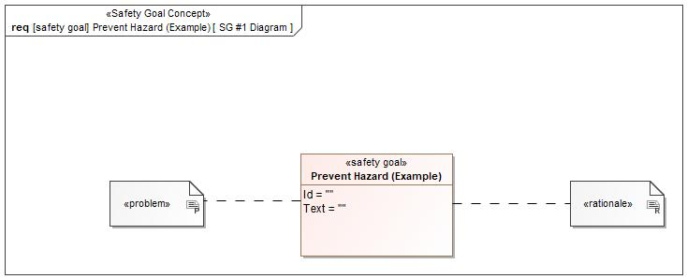

Figure 1: SG #1 Diagram – Prevent Hazard (Example)

*Note: The authoritative source for the Safety Goals is document “FFSD 02 Hazard Analysis* *and Risk Assessment”. The documentation of Safety Goals in this chapter (In the Argumentation for Safety Goal achievement) is for information purposes only.*

*The authoritative source for the Functional Safety Requirements is section 2.1.x.3: of this document. The documentation of Functional Safety Requirements in the following chapter (complete or summarised) is for information purposes only.*

#### Warning and Recovery Concept

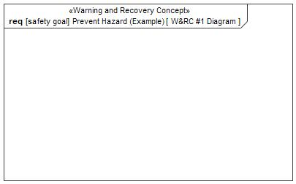

Figure 6: W&RC #1 Diagram – Prevent Hazard (Example)

### Derivation of Functional Safety Requirements on Assumptions

No Functional Safety Requirements tracing to Assumptions specified.

### ASIL Decomposition of Functional Safety Requirements

No Functional Safety Requirements with ASIL Decompositions specified.

# CyberSecurity

## Security Goals

|  |  |  |
| --- | --- | --- |
| ID | Goal | |
|  | **Goal Name** |  |
| **Description** |  |
| **CAL** |  |
| **Related CSR IDs** |  |
|  | **Goal Name** |  |
| **Description** |  |
| **CAL** |  |
| **Related CSR IDs** |  |
|  | **Goal Name** |  |
| **Description** |  |
| **CAL** |  |
| **Related CSR IDs** |  |

Table 14: Cybersecurity Goals

## Cybersecurity Requirements

# Architecture

## Functional Decomposition

### Functions

## Logical Architecture

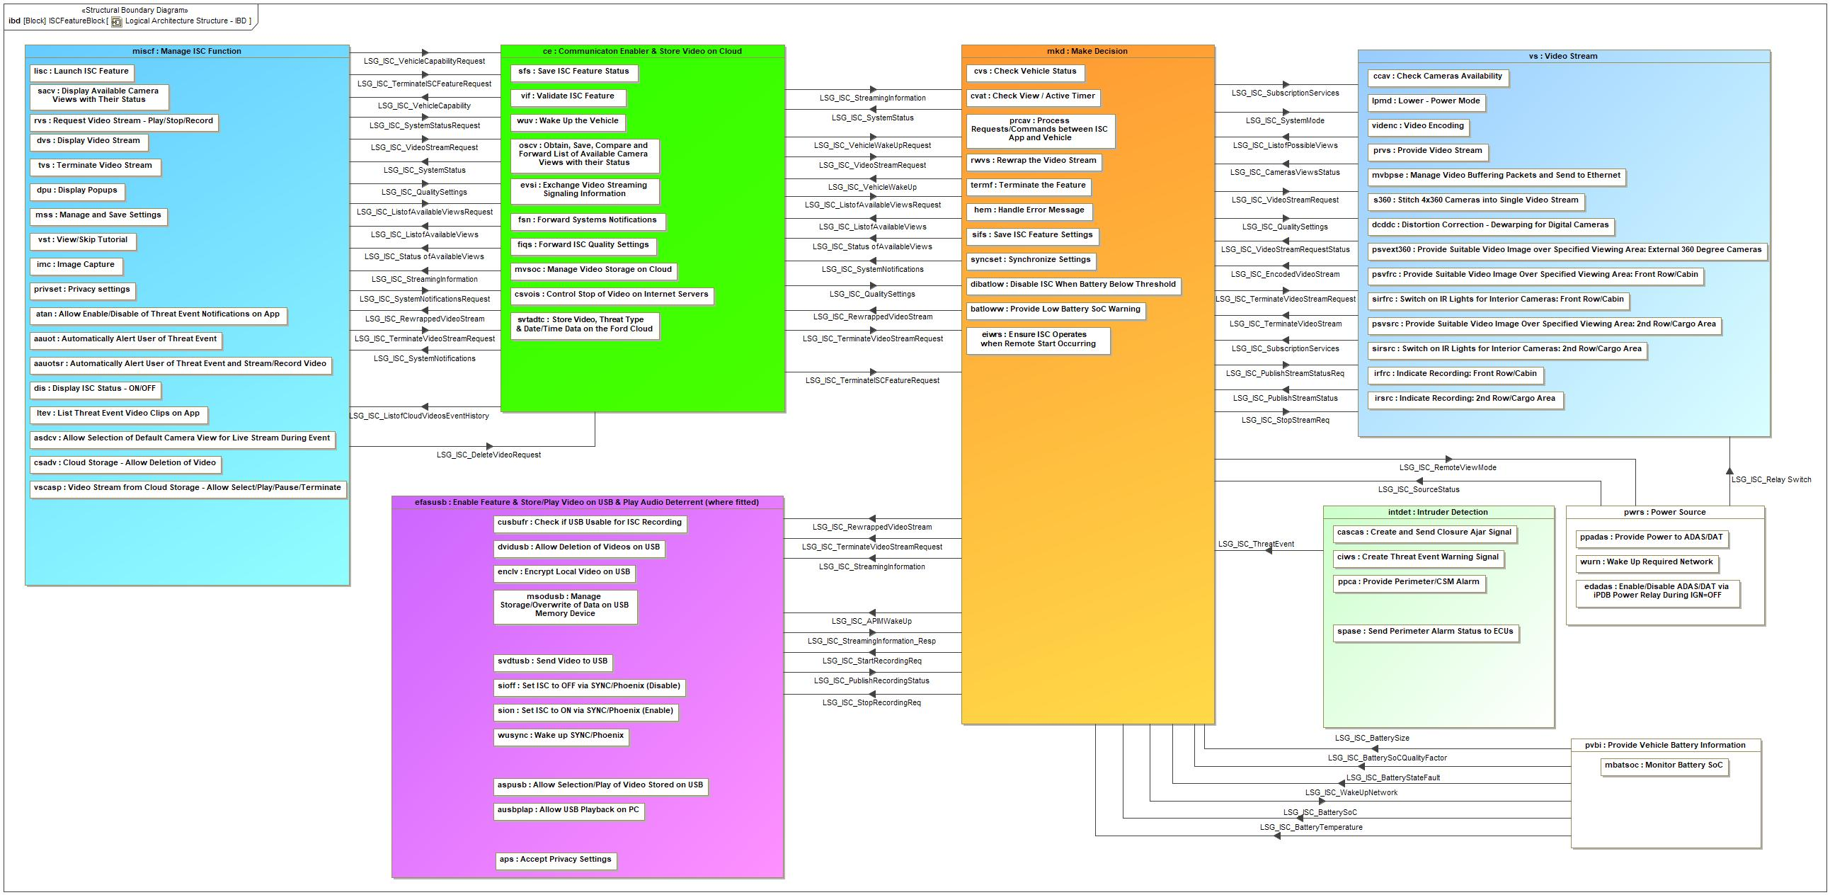

Figure 7: Logical Architecture Structure - IBD

### Logical Elements

|  |  |  |  |
| --- | --- | --- | --- |
| **Element Name** | **Description** | **Allocated Functions** | **Comments** |
| Accept Privacy Settings | Logical Hardware to Accept Privacy Settings | * Enable Feature & Store Video to USB |  |
| Allow Deletion of Videos on USB | Logical Hardware to Allow Deletion of Videos on USB | * Enable Feature & Store Video to USB |  |
| Allow Enable/Disable of Threat Event Notifications on App | Logical Hardware to Allow Enable/Disable of Threat Event Notifications on App | * Manage Ford Pass App |  |
| Allow Selection of Default Camera View for Live Stream During Event | Logical Hardware to Allow Selection of Default Camera View for Live Stream During Event | * Manage Ford Pass App |  |
| Allow Selection/Play of Video Stored on USB | Logical Hardware to Allow Selection/Play of Video Stored on USB | * Play Video from USB |  |
| Allow USB Playback on PC | Logical Hardware to Allow USB Playback on PC | * Play Video from USB |  |
| Automatically Alert User of Threat Event | Logical Hardware to Automatically Alert User of Threat Event | * Manage Ford Pass App |  |
| Automatically Alert User of Threat Event and Stream/Record Video | Logical Hardware to Automatically Alert User of Threat Event and Stream/Record Video | * Manage Ford Pass App |  |
| Check Cameras Availability | Logical Hardware to Check Cameras Availability | * Video Stream |  |
| Check if USB Usable for ISC Recording | Logical Hardware to Check if USB Usable for ISC Recording | * Enable Feature & Store Video to USB |  |
| Check Vehicle Status | Logical Hardware to Check Vehicle Status | * Make Decision |  |
| Check View / Active Timer | Logical Hardware to Check View / Active Timer | * Make Decision |  |
| Cloud Storage - Allow Deletion of Video | Logical Hardware to Cloud Storage - Allow Deletion of Video | * Manage Ford Pass App |  |
| Communicaton Enabler & Store Video on Cloud | Logical Hardware to Communicaton Enabler & Store Video on Cloud | * Store Video to Cloud * Communication Enabler & Store Video on Cloud |  |
| Control Stop of Video on Internet Servers | Logical Hardware to Control Stop of Video on Internet Servers | * Communication Enabler & Store Video on Cloud |  |
| Create and Send Closure Ajar Signal | Logical Hardware to Create and Send Closure Ajar Signal | * Intruder Detection |  |
| Create Threat Event Warning Signal | Logical Hardware to Create Threat Event Warning Signal | * Intruder Detection |  |
| Disable ISC When Battery Below Threshold | Logical Hardware to Disable ISC When Battery Below Threshold | * Make Decision |  |
| Display Available Camera Views with Their Status | Logical Hardware to Display Available Camera Views with Their Status | * Manage Ford Pass App |  |
| Display ISC Status - ON/OFF | Logical Hardware to Display ISC Status - ON/OFF | * Manage Ford Pass App |  |
| Display Popups | Logical Hardware to Display Popups | * Manage Ford Pass App |  |
| Display Video Stream | Logical Hardware to Display Video Stream | * Manage Ford Pass App |  |
| Distortion Correction - Dewarping for Digital Cameras | Logical Hardware to Distortion Correction - Dewarping for Digital Cameras | * Video Stream |  |
| Enable Feature & Store/Play Video on USB & Play Audio Deterrent (where fitted) | Logical Hardware to Enable Feature & Store/Play Video on USB & Play Audio Deterrent (where fitted) | * Enable Feature & Store Video to USB |  |
| Enable/Disable ADAS/DAT via iPDB Power Relay During IGN=OFF | Logical Hardware to Enable/Disable ADAS/DAT via iPDB Power Relay During IGN=OFF |  |  |
| Encrypt Local Video on USB | Logical Hardware to Encrypt Local Video on USB | * Enable Feature & Store Video to USB |  |
| Ensure ISC Operates when Remote Start Occurring |  |  |  |
| Exchange Video Streaming Signaling Information | Logical Hardware to Exchange Video Streaming Signaling Information | * Communication Enabler & Store Video on Cloud |  |
| Forward ISC Quality Settings | Logical Hardware to Forward ISC Quality Settings | * Communication Enabler & Store Video on Cloud |  |
| Forward Systems Notifications | Logical Hardware to Forward Systems Notifications | * Communication Enabler & Store Video on Cloud |  |
| Handle Error Message | Logical Hardware to Handle Error Message | * Make Decision |  |
| Image Capture | Logical Hardware to Image Capture | * Manage Ford Pass App |  |
| Indicate Recording: 2nd Row/Cargo Area | Logical Hardware to Indicate Recording: 2nd Row/Cargo Area | * Video Stream |  |
| Indicate Recording: Front Row/Cabin | Logical Hardware to Indicate Recording: Front Row/Cabin | * Video Stream |  |
| Intruder Detection | Logical Hardware to Intruder Detection | * Intruder Detection |  |
| Launch ISC Feature | Logical Hardware to Launch ISC Feature | * Manage Ford Pass App |  |
| List Threat Event Video Clips on App | Logical Hardware to List Threat Event Video Clips on App | * Manage Ford Pass App |  |
| Lower - Power Mode | Logical Hardware to Lower - Power Mode | * Video Stream |  |
| Make Decision | Logical Hardware to Make Decision | * Make Decision |  |
| Manage and Save Settings | Logical Hardware to Manage and Save Settings | * Manage Ford Pass App |  |
| Manage ISC Function | Logical Hardware to Manage ISC Function | * Manage Ford Pass App |  |
| Manage Storage/Overwrite of Data on USB Memory Device | Logical Hardware to Manage Storage/Overwrite of Data on USB Memory Device | * Enable Feature & Store Video to USB |  |
| Manage Video Buffering Packets and Send to Ethernet | Logical Hardware to Manage Video Buffering Packets and Send to Ethernet | * Video Stream |  |
| Manage Video Storage on Cloud | Logical Hardware to Manage Video Storage on Cloud | * Communication Enabler & Store Video on Cloud |  |
| Monitor Battery SoC | Logical Hardware to Monitor Battery SoC | * Make Decision |  |
| Obtain, Save, Compare and Forward List of Available Camera Views with their Status | Logical Hardware to Obtain, Save, Compare and Forward List of Available Camera Views with their Status | * Communication Enabler & Store Video on Cloud |  |
| Power Source | Logical Hardware to Power Source | * Power Source |  |
| Privacy settings | Logical Hardware to Privacy settings | * Manage Ford Pass App |  |
| Process Requests/Commands between ISC App and Vehicle | Logical Hardware to Process Requests/Commands between ISC App and Vehicle | * Make Decision |  |
| Provide Low Battery SoC Warning | Logical Hardware to Provide Low Battery SoC Warning | * Make Decision |  |
| Provide Perimeter/CSM Alarm | Logical Hardware to Provide Perimeter/CSM Alarm | * Intruder Detection |  |
| Provide Power to ADAS/DAT | Logical Hardware to Provide Power to ADAS/DAT | * Power Source |  |
| Provide Suitable Video Image Over Specified Viewing Area: 2nd Row/Cargo Area | Logical Hardware to Provide Suitable Video Image Over Specified Viewing Area: 2nd Row/Cargo Area | * Video Stream |  |
| Provide Suitable Video Image over Specified Viewing Area: External 360 Degree Cameras | Logical Hardware to Provide Suitable Video Image over Specified Viewing Area: External 360 Degree Cameras | * Video Stream |  |
| Provide Suitable Video Image Over Specified Viewing Area: Front Row/Cabin | Logical Hardware to Provide Suitable Video Image Over Specified Viewing Area: Front Row/Cabin | * Video Stream |  |
| Provide Vehicle Battery Information | Logical Hardware to Provide Vehicle Battery Information | * Provide Vehicle Battery Information |  |
| Provide Video Stream | Logical Hardware to Provide Video Stream | * Video Stream |  |
| Request Video Stream - Play/Stop/Record | Logical Hardware to Request Video Stream | * Manage Ford Pass App |  |
| Rewrap the Video Stream | Logical Hardware to Rewrap the Video Stream | * Make Decision |  |
| Save ISC Feature Settings | Logical Hardware to Save ISC Feature Settings | * Make Decision |  |
| Save ISC Feature Status | Logical Hardware to Save ISC Feature Status | * Communication Enabler & Store Video on Cloud |  |
| Send Perimeter Alarm Status to ECUs | Logical Hardware to Send Perimeter Alarm Status to ECUs | * Intruder Detection |  |
| Send Video to USB | Logical Hardware to Send Video to USB | * Enable Feature & Store Video to USB |  |
| Set ISC to OFF via SYNC/Phoenix (Disable) | Logical Hardware to Set ISC to OFF via SYNC/Phoenix (Disable) | * Enable Feature & Store Video to USB |  |
| Set ISC to ON via SYNC/Phoenix (Enable) | Logical Hardware to Set ISC to ON via SYNC/Phoenix (Enable) | * Enable Feature & Store Video to USB |  |
| Stitch 4x360 Cameras into Single Video Stream | Logical Hardware to Stitch 4x360 Cameras into Single Video Stream | * Video Stream |  |
| Store Video, Threat Type & Date/Time Data on the Ford Cloud | Logical Hardware to Store Video, Threat Type & Date/Time Data on the Ford Cloud | * Communication Enabler & Store Video on Cloud |  |
| Switch on IR Lights for Interior Cameras: 2nd Row/Cargo Area | Logical Hardware to Switch on IR Lights for Interior Cameras: 2nd Row/Cargo Area | * Enable Feature & Store Video to USB |  |
| Switch on IR Lights for Interior Cameras: Front Row/Cabin | Logical Hardware to Switch on IR Lights for Interior Cameras: Front Row/Cabin | * Enable Feature & Store Video to USB |  |
| Synchronize Settings | Logical Hardware to Synchronize Settings | * Make Decision |  |
| Terminate the Feature | Logical Hardware to Terminate the Feature | * Make Decision |  |
| Terminate Video Stream | Logical Hardware to Terminate Video Stream | * Manage Ford Pass App |  |
| Validate ISC Feature | Logical Hardware to Validate ISC Feature | * Communication Enabler & Store Video on Cloud |  |
| Video Encoding | Logical Hardware to Video Encoding | * Video Stream |  |
| Video Stream | Logical Hardware to Video Stream | * Video Stream |  |
| Video Stream from Cloud Storage - Allow Select/Play/Pause/Terminate | Logical Hardware to Video Stream from Cloud - Allow Select/Play/Pause/Terminate | * Manage Ford Pass App * Play Video from Cloud |  |
| View/Skip Tutorial | Logical Hardware to View/Skip Tutorial | * Manage Ford Pass App |  |
| Wake Up Required Network | Logical Hardware to Wake Up Required Network | * Power Source |  |
| Wake up SYNC/Phoenix | Logical Hardware to Wake up SYNC/Phoenix | * Enable Feature & Store Video to USB |  |
| Wake Up the Vehicle | Logical Hardware to Wake Up the Vehicle | * Communication Enabler & Store Video on Cloud |  |

Table 15: Logical Elements

### Logical Interfaces

|  |  |  |  |
| --- | --- | --- | --- |
| **Interface** | **Direction** | **Description** | **Value Range** |
| LSG_ISC_APIMWakeUp | Make Decision To Enable Feature & Store/Play Video on USB & Play Audio Deterrent (where fitted) | To wake-up the APIM (SYNC/Phoenix) |  |
| LSG_ISC_AudioDetectRequest | Communicaton Enabler & Store Video on Cloud To Make Decision | Used to request audio detection from SYNC/Phoenix |  |
| Make Decision To Enable Feature & Store/Play Video on USB & Play Audio Deterrent (where fitted) | Used to request audio detection from SYNC/Phoenix |  |
| Make Decision To Intruder Detection | Used to request audio detection from SYNC/Phoenix |  |
| Manage ISC Function To Communicaton Enabler & Store Video on Cloud | Used to request audio detection from SYNC/Phoenix |  |
| LSG_ISC_AudioDetectStream | Communicaton Enabler & Store Video on Cloud To Manage ISC Function | Used to provideaudio detection from SYNC/Phoenix |  |
| Enable Feature & Store/Play Video on USB & Play Audio Deterrent (where fitted) To Make Decision | Used to provideaudio detection from SYNC/Phoenix |  |
| Intruder Detection To Make Decision | Used to provideaudio detection from SYNC/Phoenix |  |
| Make Decision To Communicaton Enabler & Store Video on Cloud | Used to provideaudio detection from SYNC/Phoenix |  |
| LSG_ISC_AudioDeterrentRequest | Communicaton Enabler & Store Video on Cloud To Make Decision | A user request via FPA for an Audio Deterrent message to be played at/in the vehicle. |  |
| Make Decision To Enable Feature & Store/Play Video on USB & Play Audio Deterrent (where fitted) | A user request via FPA for an Audio Deterrent message to be played at/in the vehicle. |  |
| Manage ISC Function To Communicaton Enabler & Store Video on Cloud | A user request via FPA for an Audio Deterrent message to be played at/in the vehicle. |  |
| LSG_ISC_BatterySize | Provide Vehicle Battery Information To Make Decision | Used to provide the vehicle Battery Size. |  |
| LSG_ISC_BatterySoC | Provide Vehicle Battery Information To Make Decision | Used to provide the Battery SoC |  |
| LSG_ISC_BatterySoCQualityFactor | Provide Vehicle Battery Information To Make Decision | Used to provide the vehicle Battery SoC QF (State of Charge Quality Factor). |  |
| LSG_ISC_BatteryStateFault | Provide Vehicle Battery Information To Make Decision | Used to provide the vehicle Battery State Fault. |  |
| LSG_ISC_BatteryTemperature | Provide Vehicle Battery Information To Make Decision | Used to provide the vehicle battery temperature. |  |
| LSG_ISC_CamerasViewsStatus | Video Stream To Make Decision | Used to provide information on the status of the camera views |  |
| LSG_ISC_DeleteVideoRequest | Manage ISC Function To Communicaton Enabler & Store Video on Cloud | Request to delete selected video(s) and associated metadata |  |
| LSG_ISC_EncodedVideoStream | Video Stream To Make Decision | Used to provide the encoded video stream. |  |
| LSG_ISC_ListofAvailableViews | Communicaton Enabler & Store Video on Cloud To Manage ISC Function | Used to provide a list of the available camera views |  |
| Make Decision To Communicaton Enabler & Store Video on Cloud | Used to provide a list of the available camera views |  |
| LSG_ISC_ListofAvailableViewsRequest | Communicaton Enabler & Store Video on Cloud To Make Decision | Used to request the list of available camera views. |  |
| Manage ISC Function To Communicaton Enabler & Store Video on Cloud | Used to request the list of available camera views. |  |
| LSG_ISC_ListofCloudVideosEventHistory | Communicaton Enabler & Store Video on Cloud To Manage ISC Function | List of videos stored on the cloud |  |
| LSG_ISC_ListofPossibleViews | Video Stream To Make Decision | Used to provide a list of possible camera views |  |
| LSG_ISC_PublishRecordingStatus | Enable Feature & Store/Play Video on USB & Play Audio Deterrent (where fitted) To Make Decision | Used to provide the VRP status when recording is in progress |  |
| LSG_ISC_PublishStreamStatus | Video Stream To Make Decision | Used to provide the information about the ongoing streams |  |
| LSG_ISC_PublishStreamStatusReq | Make Decision To Video Stream | Used to request the information about the ongoing streams |  |
| LSG_ISC_QualitySettings | Communicaton Enabler & Store Video on Cloud To Make Decision | Used to provide the quality settings of the video stream. |  |
| Make Decision To Video Stream | Used to provide the quality settings of the video stream. |  |
| Manage ISC Function To Communicaton Enabler & Store Video on Cloud | Used to provide the quality settings of the video stream. |  |
| LSG_ISC_Relay Switch | Power Source To Video Stream | Used to control the power to the ADAS/DAT |  |
| LSG_ISC_RemoteViewMode | Make Decision To Power Source | Used to notify that the vehicle is in a remote viewing mode while in a key of state |  |
| LSG_ISC_RewrappedVideoStream | Communicaton Enabler & Store Video on Cloud To Manage ISC Function | Used for the rewrapped video stream from the ADAS/DAT |  |
| Make Decision To Communicaton Enabler & Store Video on Cloud | Used for the rewrapped video stream from the ADAS/DAT |  |
| Make Decision To Enable Feature & Store/Play Video on USB & Play Audio Deterrent (where fitted) | Used for the rewrapped video stream from the ADAS/DAT |  |
| Make Decision To Manage ISC Function | Used for the rewrapped video stream from the ADAS/DAT |  |
| LSG_ISC_SourceStatus | Power Source To Make Decision | Used to provide status of ADAS/DAT module |  |
| LSG_ISC_StartRecordingReq | Make Decision To Enable Feature & Store/Play Video on USB & Play Audio Deterrent (where fitted) | Used to send a start recording request to VRP |  |
| LSG_ISC_Status ofAvailableViews | Communicaton Enabler & Store Video on Cloud To Manage ISC Function | Used to provide the status of the available camera views |  |
| Make Decision To Communicaton Enabler & Store Video on Cloud | Used to provide the status of the available camera views |  |
| LSG_ISC_StopRecordingReq | Make Decision To Enable Feature & Store/Play Video on USB & Play Audio Deterrent (where fitted) | Used to send a stop recording request to VRP |  |
| LSG_ISC_StopStreamReq | Make Decision To Video Stream | Used to stop the ongoing stream |  |
| LSG_ISC_StreamingInformation | Communicaton Enabler & Store Video on Cloud To Make Decision | Used to provide the streaming credential information to ECG |  |
| Communicaton Enabler & Store Video on Cloud To Manage ISC Function | Used to provide the streaming credential information to ECG |  |
| Make Decision To Enable Feature & Store/Play Video on USB & Play Audio Deterrent (where fitted) | Used to provide the streaming credential information to ECG |  |
| LSG_ISC_StreamingInformation_Resp | Enable Feature & Store/Play Video on USB & Play Audio Deterrent (where fitted) To Make Decision | Used to provide the streaming credential information to Cloud |  |
| LSG_ISC_SubscriptionServices | Make Decision To Video Stream | Used to provide the status of subscription details |  |
| Video Stream To Make Decision | Used to provide the status of subscription details |  |
| LSG_ISC_SystemMode | Make Decision To Video Stream | Used to provide the status of ISC feature ON/OFF |  |
| LSG_ISC_SystemNotifications | Communicaton Enabler & Store Video on Cloud To Manage ISC Function | Used to provide the vehicle status (e.g. battery, ignition or connectivity etc..) when feature is in use |  |
| Make Decision To Communicaton Enabler & Store Video on Cloud | Used to provide the vehicle status (e.g. battery, ignition or connectivity etc..) when feature is in use |  |
| LSG_ISC_SystemNotificationsRequest | Manage ISC Function To Communicaton Enabler & Store Video on Cloud | Used to request the vehicle status from ECG when the feature is in use |  |
| LSG_ISC_SystemStatus | Communicaton Enabler & Store Video on Cloud To Manage ISC Function | Used to provide the system status of ISC feature ON/OFF |  |
| Make Decision To Communicaton Enabler & Store Video on Cloud | Used to provide the system status of ISC feature ON/OFF |  |
| LSG_ISC_SystemStatusRequest | Manage ISC Function To Communicaton Enabler & Store Video on Cloud | Used to request the system status of ISC feature ON/OFF when feature in use |  |
| LSG_ISC_TerminateISCFeatureRequest | Communicaton Enabler & Store Video on Cloud To Make Decision | Used to request the termination of the feature |  |
| Manage ISC Function To Communicaton Enabler & Store Video on Cloud | Used to request the termination of the feature |  |
| LSG_ISC_TerminateVideoStream | Video Stream To Make Decision | Used to terminate the video stream |  |
| LSG_ISC_TerminateVideoStreamRequest | Communicaton Enabler & Store Video on Cloud To Make Decision | Used to request termination of the video stream |  |
| Make Decision To Enable Feature & Store/Play Video on USB & Play Audio Deterrent (where fitted) | Used to request termination of the video stream |  |
| Make Decision To Video Stream | Used to request termination of the video stream |  |
| Manage ISC Function To Communicaton Enabler & Store Video on Cloud | Used to request termination of the video stream |  |
| LSG_ISC_ThreatEvent | Intruder Detection To Make Decision | Signal indicating that a threat event has occurred at the vehicle |  |
| LSG_ISC_VehicleCapability | Communicaton Enabler & Store Video on Cloud To Manage ISC Function | Used to provide the capability status of the VIN for ISC feature |  |
| LSG_ISC_VehicleCapabilityRequest | Manage ISC Function To Communicaton Enabler & Store Video on Cloud | Used to request the capability status of the VIN for ISC feature |  |
| LSG_ISC_VehicleWakeUp | Make Decision To Communicaton Enabler & Store Video on Cloud | Used to wake-up the vehicle by using wake-up SMS |  |
| LSG_ISC_VehicleWakeUpRequest | Communicaton Enabler & Store Video on Cloud To Make Decision | Used to request the wake-up of the vehicle by using wake-up SMS |  |
| LSG_ISC_VideoStreamRequest | Communicaton Enabler & Store Video on Cloud To Make Decision | Used to request the video stream |  |
| Make Decision To Video Stream | Used to request the video stream |  |
| Manage ISC Function To Communicaton Enabler & Store Video on Cloud | Used to request the video stream |  |
| LSG_ISC_VideoStreamRequestStatus | Video Stream To Make Decision | Used to provide the status of the video stream request |  |
| LSG_ISC_WakeUpNetwork | Make Decision To Provide Vehicle Battery Information | Used to wake-up the required CAN network |  |

Table 16: Feature Interactions

# Traceability Matrix

# Open Concerns

| ID | Concern Description | e-Tracker / Reference | Responsible | Status | Solution |
| --- | --- | --- | --- | --- | --- |
| 1 |  |  |  |  |  |

Table 17: Open Concerns *(Not supported by MagicDraw report generation)*

# Revision History

| Rev.  (revision) | Date | Description | Approved by | Responsible |
| --- | --- | --- | --- | --- |
| FD1 | 2020-11-26 | FD V1.0 |  |  |
| FDV2.7 (V710) | 2021-05-20 | Updated requirements etc., especially for camera team |  |  |
| FD3.0 (Phoenix) | 2021-06-17 | Updated for Phoenix. |  |  |
| FD 3.2 (CDX747) | 2021-10-20 | Updated for ISC |  |  |
| FD 3.3(CDX747) | 2021-10-21 | Updates to format and variant descriptions |  |  |
| FD3.4(V710) | 2021-11-10 | Requirements updated – first ISC FD for V710 |  |  |
| FD3.5(CDX747) | 2021-11-10 | Requirements updated |  |  |
|  |  |  |  |  |
|  |  |  |  |  |

## Template Revisions

|  |  |  |  |  |
| --- | --- | --- | --- | --- |
| Version | Rev. | Date | Description | Responsible |
| 0 | 6 | 2015-05-26 | * Chapter “Feature Overview” and made a 2nd level heading. * Chapter “Feature Modeling” divided into 3 subchapter (“Scenarios”, “Use Cases”, “State Machines”) for different modeling methods | Jbaden1 |
| 0 | 7 | 2015-05-27 | * Table of Content updated * Template Revision History chapter added | Jbaden1 |
| 0 | 8 | 2015-07-02 | * Section “Unsettled Issues” added | Alevin7 |
| 0 | 9 | 2015-08-04 | * Section “Feature Variants” added * Section “Feature Boundary Diagram” renamed to “Feature Context Diagram” * Document Properties adapted to match needs of VBA macros | Jbaden1, Awegman1 |
| 1 | 0 | 2015-09-11 | * Section “Feature Variants” reworked * Feature Goals removed. Only “Safety Goals“ chapter remains. * Heading 2 formatting issues corrected. * Requirements / Use Cases Listing removed from traceability chapter. * Formatting of attribute table in Notation chapter corrected * Open Topics / Known Issues chapter moved to the end | Jbaden1 |
| 1 | 1 | 2015-11-16 | * Table-Styles removed (for smooth VSEM import) * Some clean-up of sections “Purpose” and “Audience” | Awegman1, jbaden1 |
| 1 | 2 | 2016-02-26 | * Minor corrections based on lessons learned from CC and PCL pilot (e.g. section market/regions) and discussion with Functional Safety Team (purpose of feature) * Footer corrected * Boundary diagram interface chapter renamed to influences. | Jbaden1 |
| 1 | 3 | 2016-02-26 | * Minor corrections after review with Whitney Keith from Functional Safety team | Jbaden1 |
| 1 | 4 | 2016-03-10 | * Some cleanup of meta-data in Word Properties | Jbaden1 |
| 1 | 5 | 2016-03-10 | * Footer formatting corrected (Issue 19) * Results from review with Functional Safety Team incorporated (Issue 20). | jbaden1 |
| 1 | 6 | 2016-04-18 | * Scenario Template added | Jbaden1 |
| 1 | 7 | 2016-04-18 | * Chapter “Operation Modes and States” moved before “Use Case” section. | Jbaden1 |
| 1 | 8 | 2016-04-18 | * Broken Wiki links repaired. | Jbaden1 |
| 2 | 0 | 2016-05-19 | * Adapted to Specification_Macros.dotm V2.0 * Requirements Templates chapter (ch. 1.7.1) no longer has an attribute table, but refers directly to the Wiki.. | Jbaden1 |
| 2 | 1 | 2016-06-10 | * Table for Context Diagram modified (lists external entities and Influence Description only) | Jbaden1 |
| 2 | 2 | 2016-07-08 | * Template version added to footer * Several hints added to the various sections * Findings from Functional Safety Team incorporated. * RE_SafetyRequirement style added | Jbaden1 |
| 2 | 3 | 2016-09-21 | * Update from Functional Safety Team incorporated (“Lessons Learned”, “System Behaviors for HARA”) | Jbaden1 |
| 2 | 4 | 2016-11-15 | * Update from Functional Safety Team incorporated (“Lessons Learned”, “System Behaviors for HARA”) * Explanatory notes made more formal | Jbaden1 |
| 3 |  |  | Skipped to synchronize with Specification_Macros.dotm |  |
| 4 |  |
| 5 | 0 | 2017-01-13 | * Meta data updated for specification macros, version 3.1 * SW Unit chapter removed for the time being * Green boxes added for user hints | Jbaden1 |
| 5 | 1 | 2017-01-18 | * Minor editorial changes | Jbaden1 |
| 6 | 0 | 2017-02-03 | * CR48: Chapter 6 renamed from “Safety” to “Functional Safety”. New sub-chapter “Safety” introduced in Non-Functional Requirements section | Jbaden1 |
| 6 | 0 | 2017-04-28 | * CR7: “RequirementsTraceability” chapter removed | Jbaden1 |
| 6 | 0 | 2017-11-15 | * CR32/53: New Cover Sheet + Disclaimer replaces FAP-150 like ones. * CR75: Some rewording -> Terminology to Glossary, Notation -> Document Conventions * CR49: Rename “Assumptions & Constraints” to “Assumptions” * CR74: Safety Assumptions added to chapter 6. * CR58: Add function allocation column to Logical Architecture chapter | Jbaden1 |
| 6 | 0 | 2018-01-31 | * CR63: Updated links to Functional Safety Sharepoint | Jbaden1 |
| 6 | 0 | 2018-07-24 | * CR69: Add FSR to FeatureDoc * CR64: Add new section "Design Requirements" to Function Spec and Feature Spec | Jbaden1 |
| 6 | 0 | 2018-08-06 | * CR53: some corrections for metada and formatting | Jbaden1 |
| 6 | 0 | 2018-09-28 | * Broken links to RE Wiki repaired | Jbaden1 |
| 6 | 0 | 2018-10-31 | * Cover sheet and footer more GIS like. Functional Safety team feedback incorporated:   + New subsections “Functional Safety Requirements, (Decomposed) FSRs and Parameters / Values   + Removal of “Logical Architecture” | Jbaden1 |
| 6 | 0 | 2018-12-12 | * FSR template removed, now as a macro in the Specification_Macros.dotm | Jbaden1 |
| 6 | 0a | 2019-05-23 | * Re-introduce “Logical Architecture” (for Functional Safety) | Jbaden1 |
| 6 | 0b | 2019-06-26 | * Chapter “Logical Elements” in “Logical Architecture” section added (FuSa CR 15136240) | Jbaden1 |
| 6 | 0c | 2019-03-22 | * Chapter “Decomposed FSRs” renamed to “ASIL Decomposition of Functional Safety Requirements” and moved beneath Chapter “Functional Safety Requirements”. Explanatory text improved. | Jbaden1 |
| 6 | 0c | 2019-04-05 | * Some wording in ASIL decomposition table modified. Description of fields in that table improved. | Jbaden1 |
| 6 | 0c | 2019-06-24 | * “Input Requirements” section modified (table approach as for the other RE templates). * “References” and “Glossary” chapter moved to the “Introduction” chapter. | Jbaden1 |
| 6 | 0c | 2019-07-02 | * "Important" box added on cover sheet which points to the macros | Jbaden1 |
| 6 | 0c | 2019-07-02 | * Subsection “Error Handling” removed form chapter “Feature Requirements”->”Functional Requirements” (teams are free to create their own substructure of that section). Note tells author not to forget about error handling. * Hint for chapter “Feature Variants” improved reworded upon request from Functional Safety Team. | Jbaden1 |
| 6 | 0c | 2019-05-11 | * Copyright notice shortened and moved to cover sheet and added to footer (to be compliant [with Ford copyright guidelines](http://www.fgti.ford.com/client/NewFGTI/CopyrightNotice.html)) * Term “Disclaimer” no longer used for what is actually only a copyright notice | Jbaden1 |
| 6 | 0c | 2019-22-11 | * Chapter “Input Requirements/Documentst: minor modifications (examples added), Word comment removed” | Jbaden1 |
| 6 | 0c | 2019-12-05 | * Upstream Documents section added to “Input Requirements/Documents” table * Custom style table formatting removed * Hint on system behaviors modified as requested from FuSa team | Jbaden1 |
| 6 | 0c | 2019-12-09 | * Term “Upstream Documents” replaced by “Attribute Requirements” in “Input Requirements/Documents” table * ASIL Decomposition table replaced by a version, which get not corrupted during VSEM import. | Jbaden1 |
| 6 | 0c | 2019-12-10 | * In ch. “Functional Safety Requirements” Word reference Id by Word reference text replaced.. | Jbaden1 |
| 6 | 1a | 2020-02-12 | * New chapter “Cybersecurity” added. | Jbaden1 |
| 6 | 1a | 2020-03-03 | * All User Hints formatted using style “RE_UserHint” to enable automatic removal by a macro. | Jbaden1 |
| 6 | 1a | 2020-03-04 | * Chapter “Cloud Connectivity Data Analytics Requirements” added upon request by D. Crockett/J. Rawlings | Jbaden1 |
| 6 | 1a | 2020-03-09 | * Missing doc property “LatestSigMappingID” and “LatestAisInterfaceID” added * doc property “CopyrightDate” re-formatted to text and copyright date field in footer corrected * Version numbering re-initialized as 0.1 * Init value of version/revision date set to “yyyy/mm/dd” instead of “yyyy-mm-dd” to be in line with the “Edit Document Property” dialog * type of document property for latest IDs changed to number instead of text | Jbaden1 |
| 6 | 1b | 2020-03-17 | * Chapter “Functional Architecture” renamed to “Functional Decomposition” * New MBSE terminology introduced: “Feature Level”, “Function Level” and “Component Level” renamed to “Concept Level”, “Logical Level” and “Technology Level” | Jbaden1 |
| 6 | 1b | 2020-07-03 | * CR31: Chapter “Traceability Matrix” added. | Jbaden1 |
| 6 | 1b | 2020-23-09 | * CR28: Alignment to [*FFSG01.10 Feature Document Guideline*](https://azureford.sharepoint.com/sites/GlobalFunctionalSafety/Released%20Templates%20Guidelines%20and%20Examples/Guidelines/FFSG01.10_FeatureDocument_Guideline.pdf) for how to apply the Feature Doc template for Functional Safety. New section “Classification of Chapters” added. “Active Tilt Control” Example in section “Logical Architecture” updated based on input from HARA training. | Jbaden1 |
| 6 | 1b | 2020-25-11 | * Reference to process definition in Stages added to “How to Use” section on cover sheet. User hints removed from “Document Purpose” chapter. * RE-Wiki links mostly replaced by Stages links, links to Functional Safety Sharepoint updated | Jbaden1 |

# Appendix

## Definitions

| **Definition** | **Description** |
| --- | --- |
| Kinesis | Amazon Kinesis Data Streams (KDS) is a massively scalable and durable real-time data streaming service. The data collected is available in milliseconds to enable real-time analytics use cases such as real-time dashboards, real-time anomaly detection, dynamic pricing, and more. |
| WebRTC | WebRTC is an open technology specification for enabling real-time communication (RTC) across browsers and mobile applications via simple APIs. |

Table 18: Definitions used in this document

## Abbreviations

| **Abbr.** | **Stands for** |
| --- | --- |
| ADAS | Advanced Driver Assistance Systems |
| APCA & CCS Cloud | AppLink Policies Cloud Application & Customer Connectivity Settings |
| APP | Application (ie software application) |
| BCM | Body Control Module |
| CAN | Controller Area Network (CAN bus) |
| CSM | Central Security Module |
| CVFMA | Connected Vehicle Feature Management Application |
| DAT | Driver Assistance Technologies |
| DCM | Door Control Module |
| DDSM | Digital Data Storage Module |
| ECG | Enhanced Central Gateway |
| EM | Electro-Magnetic |
| FPA | Ford Pass App (application). The App on the mobile the customer uses to view different cameras available to monitor the vehicle |
| HU | Head Unit |
| iPDB | intelligent Power Distribution Box |
| IR | Infra Red, or Implementation Requirement |
| ISC | Integrated Security Camera |
| KDS | Kinesis Data Streams |
| LIN | Local Interconnect Network |
| MDVVC | Mobile Device Viewer for Vehicle Cameras |
| OTA | Over the Air Updates |
| RTC | Real Time Communications |
| RTP | Real-time Transport Protocol |
| SEM | Sensor Extension Module |
| SoC % | State of Charge percentage. Percentage of the vehicle battery charge that is available. |
| SoC QF | State of Charge Quality Factor. Determine the reliability of the vehicle battery information values. |
| SoC SF | State of Charge Sensor Fault. Determines the fault status of the state of charge sensor. |
| SSP | Subscription Services Platform |
| SYNC | In vehicle HMI including in car entertainment etc. |
| TCU | Telematics Control Unit |
| TMC | Transportation Mobility Cloud |
| US | Ultra Sonic |
| USB | Universal Serial Bus |
| VOE | Video Over Ethernet |
| VPSM | Vehicle Power State Manager / Variable Power Moding system |
| VRP | Video Recording and Playback |
| VRS | Video RecordierService |

Table 19: Abbreviations used in this document

Document ends here.